LBTR08F

8-port 10/100BASE-TX Industrial Ethernet Switch

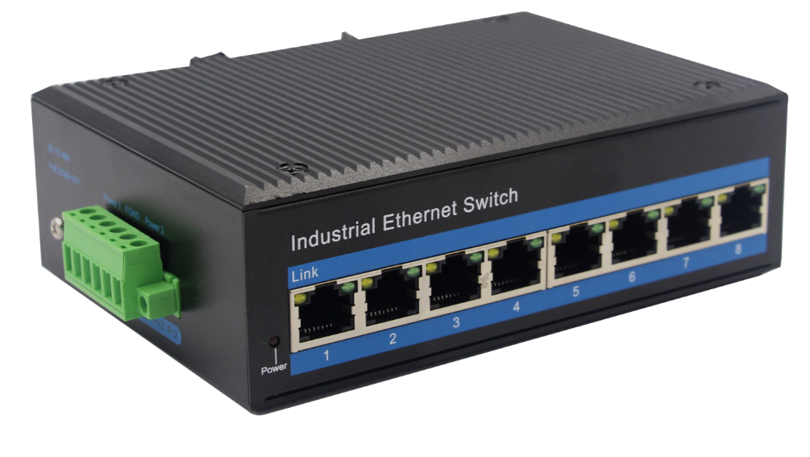
Interface
- 8-port 10/100Base-Tx RJ-45 with auto negotiation and auto-MDI/MDI-X function
Industrial conformance
- 12V to 52V DC, redundant power input
- -40℃ to 80℃ operating temperature
- IP40 Aluminum housing
- Supports 6KV DC Ethernet ESD protection
- Supports 6KV DC EFT protection for power line
- Free Fall, Shock and Vibration Stability
- DIN-rail and wall-mountable hardware design

Slim Type with more Practicability and Convenience
LBTR08F an hardened 8-port Industrial Ethernet Switch, provides non-blocking wire-speed performance in harsh industrial environment. It also provides 8-port 10/100/100BASE-TX RJ45 copper interfaces delivered in an IP40 rugged, strong case with redundant power system. Its slim case is suitable for such applications as surveillance system deployments, control management and wireless service in climatically demanding environments with wide temperature range from -40 to 80 degree

The LBTR08F series provides the flexibility to all kinds of 10/100Mbps Ethernet Media on RJ-45 port and performs highly stable fiber performance.

The LBTR08F series is packaged in a compact IP40 case that allows either DIN rail or panel mounting to have efficient usage of cabinet space. It provides an integrated power supply with a wide range of voltages for worldwide operation. It also offers dual-redundant, reversible polarity 12V DC to 52V DC power supply inputs for high availability applications requiring dual or backup power inputs.

Specifications:
Model No. | LBTR08F
10/100BASE-TX Port | 8 port RJ-45 auto-MDI / MDI-X
Performance Specification | Bandwidth: 1.6Gbps  Packet Buffer Memory:1Mbit  Packet Forwarding Rate:1.2Mpps  MAC Address Table: 2K
Installation | DIN rail
Maximum Frame Size | 9000bytes packet size
Flow Control | Back pressure for half duplex, IEEE 802.3x pause frame for full duplex
Enclosure | IP40 aluminum housing
LED Indicator | Power: Red  Ethernet: Yellow  POE: Green
Power Input | 12 to 52V DC redundant power
Power Consumption | 3 watts max
Surge protection | ±4KV
Network Protocols | IEEE802.3 10BASE-T;  IEEE802.3i 10Base-T;  IEEE802.3u;100Base-TX/FX;
Network cables | 10BASE-T: Cat3,4,5 UTP(≤100 meter)  100BASE-TX: Cat5 or later UTP(≤100meter)  1000BASE-TX: Cat6 or later UTP(≤100 meter)
Industry Standard | FCC CFR47 Part 15,EN55022/CISPR22, Class A  IEC61000-4-2 (ESD): ±8kV (contact), ±12kV (air)  IEC61000-4-3 (RS): 10V/m (80~1000MHz)  IEC61000-4-4 (EFT): Power Port: ±4kV; Data Port: ±2kV  IEC61000-4-5 (Surge): Power Port: ±2kV/DM, ±4kV/CM; Data Port: ±2kV  IEC61000-4-6 (CS): 3V (10kHz-150kHz); 10V (150kHz-80MHz)  IEC61000-4-16 (Common mode conduction): 30V (cont.), 300V (1s)
Certification | CE FCC Rohs compliance
MTBF | >300,000hours
Dimensions (W x D x H) | 143.7 x 103 x 47.7 mm
Weight | Product Weight: 0.52KG  Packing Weight: 0.62KG
Working Environment | Working temperature: -40-80 degree ;  Storage temperature: -40-80 degree ;  Relative Humidity: 5%~95 %( no condensation)
Warranty | 1-year replacement with new item; 3-years for main parts.
Dimensions
