LBTR11F Series
10/100Base-TX to 100Base-FX Industrial Media Converter

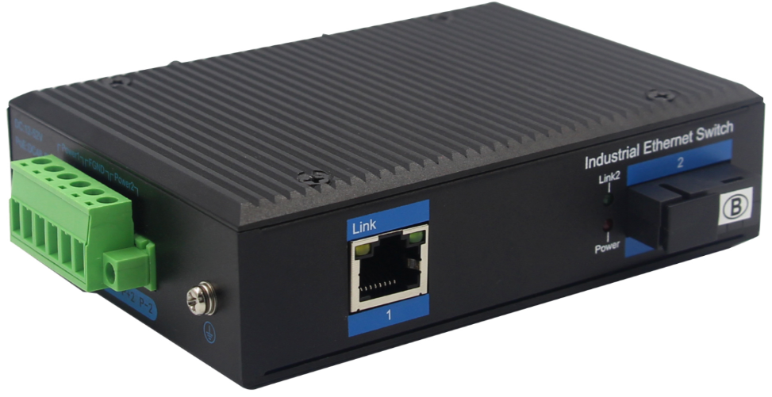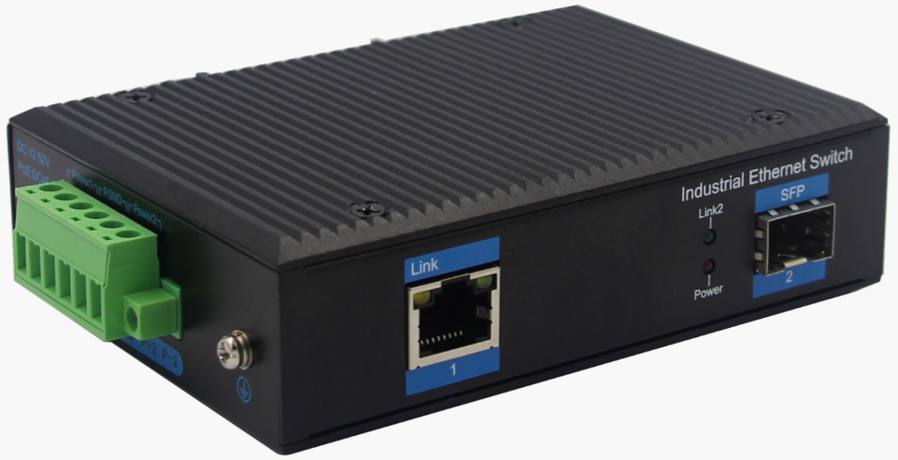
Interface
- 1-port 10/100Base-Tx RJ-45 with auto negotiation and auto-MDI/ MDI-X function
- 1-port 100Base-Fx interface SC/FC/ST/SFP
- Multi-Mode up to 2km
- Single-Mode up to 20km/40km/60km/80km

Industrial conformance
- 12V to 52V DC, redundant power input
- -40℃ to 80℃ operating temperature
- IP40 aluminum housing
- Supports 6KV DC Ethernet ESD protection
- Supports 6KV DC EFT protection for power line
- Free Fall, Shock and Vibration Stability
- DIN-rail and wall-mountable hardware design

Distance extending Slim Type with more Practicability and Convenience
10/100Base-TX to 100Base-FX Industrial Media Converter, extends communication distance with stable performance via fiber optic wire, in which the extended distance could be up to 2km with the LBTR11F, up to 20km with the ZXR11F-SC20 .

The LBTR11F series is specifically equipped with durable components and strong housing case to operate reliably in electrically harsh and climatically demanding environments. The industrial level media converter provides a high level of immunity to electromagnetic interference and heavy electrical surges which are usually found on plant floors or traffic control cabinets on sidewalk. Being able to operate under the temperature range from -40℃ to 80℃ allows the ZXR11F series to be placed in almost any difficult environment.
LBTR11F 10/100Base-TX to 100Base-FX Industrial Media Converter series efficiently converts data between 10/100Base-TX and 100Base-FX network. The ZXR11F series provides the flexibility to all kinds of 10/100Mbps Ethernet Media on RJ-45 port and performs highly stable fiber performance.
The LBTR11F series is packaged in a compact IP40 case that allows either DIN rail or panel mounting to have efficient usage of cabinet space. It provides an integrated power supply with a wide range of voltages for worldwide operation. It also offers dual-redundant, reversible polarity 12V DC to 52V DC power supply inputs for high availability applications requiring dual or backup power inputs.

Specifications:
ROBOT
ROBOT
Model No. | LBTR11F-SC2 / LBTR11F-SC20 / LBTR11F-SFP
10/100Base-TX Port | 1 port RJ-45 auto-MDI / MDI-X
100Base-FX Port | LBTR11F-SC2: 1 SC interface  LBTR11F-SC20: 1 SC Interface  LBTR11F-SFP: 1 SFP Slot
Fiber Port Type | LBTR11F-SC2:: SC / multi-mode ,up to distance 2km ;  LBTR11F-SC20: SC / single-mode ,up to distance 20km ;  LBTR11F-SFP: Vary on module
Optical Frequency | LBTR11F-SC2: 1310nm  LBTR11F-SC20: 1310nm  LBTR11F-SFP: Vary on module
Performance Specification | Bandwidth: 1.6Gbps  Packet Buffer Memory:1Mbit  Packet Forwarding Rate:1.2Mpps  MAC Address Table: 2K
Installation | DIN rail
Maximum Frame Size | 9000bytes packet size
Flow Control | Back pressure for half duplex, IEEE 802.3x pause frame for full duplex
Enclosure | IP40 aluminum housing
LED Indicator | Power: Red  Fiber: Link 2(Green)  Ethernet: Yellow
Power Input | 12 to 52V DC redundant power
Power Consumption | < 3 watts
Surge protection | ±4KV
Network Protocols | IEEE802.3 10BASE-T;  IEEE802.3i 10Base-T;  IEEE802.3u;100Base-TX/FX;
Network cables | 10BASE-T: Cat3,4,5 UTP(≤100 meter)  100BASE-TX: Cat5 or later UTP(≤100meter)  1000BASE-TX: Cat6 or later UTP(≤100 meter)
Industry Standard | FCC CFR47 Part 15,EN55022/CISPR22, Class A  IEC61000-4-2 (ESD): ±8kV (contact), ±12kV (air)  IEC61000-4-3 (RS): 10V/m (80~1000MHz)  IEC61000-4-4 (EFT): Power Port: ±4kV; Data Port: ±2kV  IEC61000-4-5 (Surge): Power Port: ±2kV/DM, ±4kV/CM; Data Port: ±2kV  IEC61000-4-6 (CS): 3V (10kHz-150kHz); 10V (150kHz-80MHz)  IEC61000-4-16 (Common mode conduction): 30V (cont.), 300V (1s)
Certification | CE FCC Rohs compliance
MTBF | >300,000hours
Dimensions (W x D x H) | 118 x 86 x 39 mm
Weight | Product Weight: 0.36KG  Packing Weight: 0.46KG
Working Environment | Working temperature: -40～80℃ ;  Storage temperature: -40～80℃  Relative Humidity: 5%~95 %( no condensation)
Warranty | 1-year replacement with new item; 3-years for main parts.

Dimensions
