LBTR12F Fast Industrial Ethernet Switch User manual

- Overview
Industrial Ethernet switch with 2-Port 10/100Mbps RJ45 +1 Port 100Mbps base-FX , the Product meet CE,FCC, RoHS standards.LBTR12F switch has the operating temperature of -40℃ ~ 80℃, has the super firmness can adapt to all kinds of harsh environment, can also be conveniently placed in the compact space of the control box. The installation characteristics of the guide rail, wide temperature operation, IP40 protection class housing and LED indicator light make the LBTR12F a plug and play industrial grade device, providing a reliable and convenient solution for users to network their Ethernet devices.

- Switch Panel
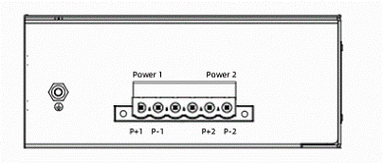
LBTR12F Side panel: P1 and P2 are the number of connecting terminals, P+1 and P-1 are respectively to the positive and negative poles to be connected; Earthing screw, used for earthing equipment.
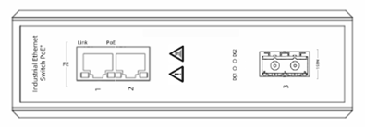
LBTR12F Front panel: The orange light on the port is the LINK light, which is on when the connection is established and the data transmission is flashing. The green light is POE light, which is only on when the switch port is supplying power to the PD devices (this model is optional with PoE); Power indicator light is on when connecting with Power.
Switch size（mm）
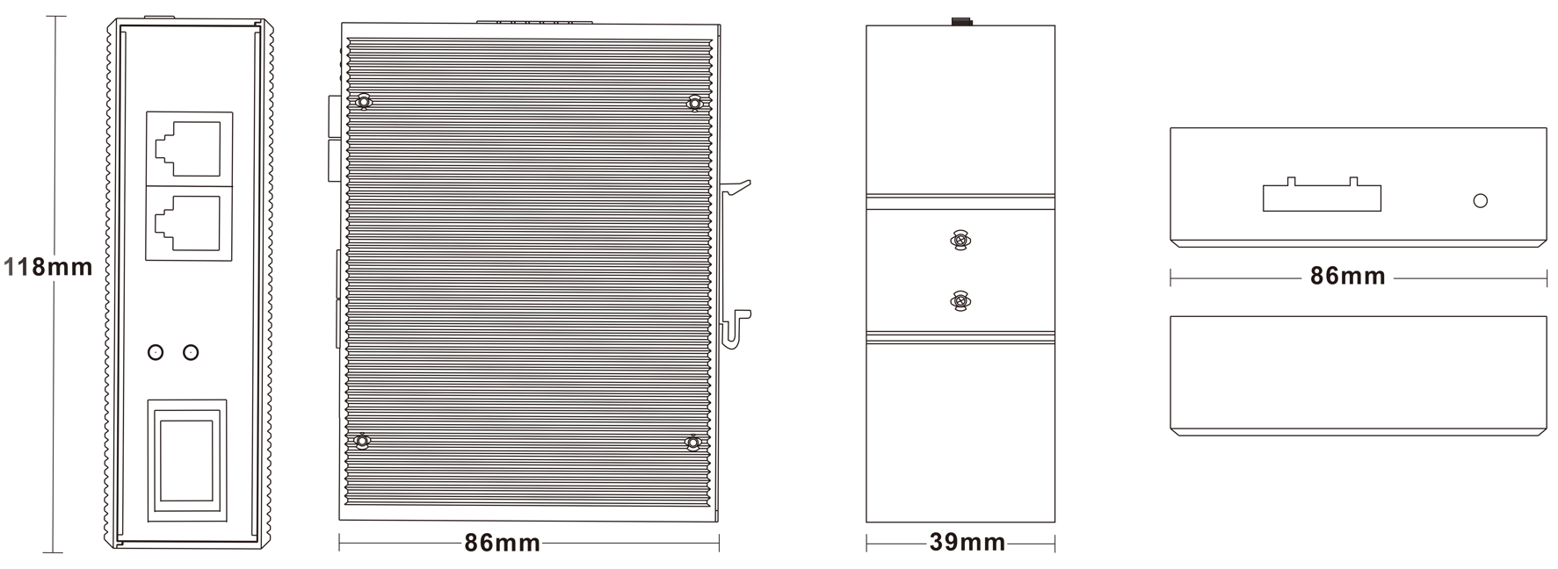

3. Features
● The use of high quality photoelectric integration module to provide good optical and electrical characteristics
● Ensure reliable data transmission and long working life
● Support full duplex or half duplex mode, with automatic negotiation capability
● Network port support automatic cross identification
● Internal storage and forwarding mechanism, support a variety of protocols
● In line with industrial operating standards, the average trouble-free work in more than 300,000 hours
● Working power supply: DC 12-52V to provide reverse protection
● Lightning Surge Protection (Power): 5000A(8/20μs)

4. Specification
4.1 Standard:IEEE802.310BASE-TIEEE802.3i 10Base-T;IEEE802.3u;100Base-TX/FX
4.2 Interface: 2-Port 10/100Mbps RJ45+1 Port 100Mbps base-FX Industrial Switch
4.3 Work environment: -40～80 °C
Storage: -40～80 °C
4. 4 Switch:
Bandwidth: 1.6Gbps
Packet Buffer Memory:1Mbit
Packet Forwarding Rate:1.2Mpps
MAC Address Table: 2K
4.5 Power supply: input voltage: DC12-52V (two-way power redundancy backup); Access terminal: Phoenix terminal; Support dual power redundancy; Support built-in over current 4.0A protection;
Support reverse connection protection
Max Power consumption: 3W
4.6 Mechanical characteristic：
IP40 aluminum housing
DIN rail install
Natural colling, no fan
Weight: 0.36Kgs
Measurement: 118 x 86 x 39 mm
4.7 Industrial standard:
FCC CFR47 Part 15,EN55022/CISPR22, Class A
IEC61000-4-2 (ESD): ±8kV (contact), ±12kV (air)
IEC61000-4-3 (RS): 10V/m (80~1000MHz)
IEC61000-4-4 (EFT): Power Port: ±4kV; Data Port: ±2kV
IEC61000-4-5 (Surge):Power Port: ±2kV/DM, ±4kV/CM; Data Port: ±2kV
IEC61000-4-6 (CS): 3V (10kHz-150kHz); 10V (150kHz-80MHz)
IEC61000-4-16 (Common mode conduction): 30V (cont.), 300V (1s)
Frequency range：150kHz-80MHz
Impact: IEC 60068-2-27
Free Fall: IEC 60068-2-32
Vibration: IEC 60068-2-6

5. Interface Definition
10/100Base-TX ethernet interface:
This series of switches provides MDI/MDI-X self-identification with cable support on all 10/100Basc-TX ports. In use, the Ethernet port of the switch can be connected with other Ethernet terminal devices through network cables (direct or cross).Please use Class 5 shielded twisted pair. The Ethernet port pin definition is shown in the following figure:
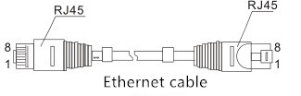
RJ45 port supports automatic MDI/MDI-X operation, you can use a straight line to connect to the PC or server, connect to other switches or hubs. In the through line (MDI), pins 1, 2, 3, 4, 5, 6, 7, 8 correspond to the connection; For the MDI-X port of a switch or hub, cross lines are used: 1-3, 2-6, 3-1, 6-2, 4-7, 5-8, 7-4, 8-5.10Base-T/100Base-T (X) pins are defined as follows:
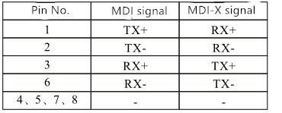
Note: "Tx ±" refers to sent data ±, "Rx ±" refers to received data ±, and "-" refers to unused data.
5.2 100base-FX ethernet interface
This device provides 100Base single-mode dual-fiber SC module, and multi-mode like LC, ST as optional.
5.2.1 Patch cord classification
According to the transmission mode of light in the fiber, it can be divided into multi-mode fiber and single-mode fiber.Multimode fiber has a thick glass core (50 or 62.5μm), which can transmit light in various modes.However, the high inter-mode dispersion limits the frequency at which digital signals can be transmitted, so multimode fibers can be transmitted over relatively close distances (typically only a few kilometers).
The single-mode fiber has a very thin glass core (core diameter, usually 9 or 10μm) and can transmit only one mode of light.Therefore, its inter - module dispersion is very small, and it is suitable for remote communication.Under normal circumstances, the skin is orange for multi-mode, yellow for single mode.
5.2.2 Patch cord overview
SC to SC patch cord
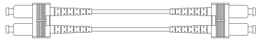
ST to ST patch cord
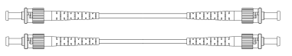
FC to FC patch cord
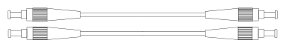
LC to LC patch cord
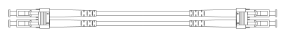

6. LED Indicator
LED indicator | Status | Definition
Power | Red LED on | Power supplying in normal
Power | Red LED off | Power supply abnormal or no powering
RJ45 indicator | Yellow LED on | Network connection in normal
RJ45 indicator | Yellow LED flashing | Link communication in normal
RJ45 indicator | Green LED on | PoE feeding in normal
RJ45 indicator | Yellow/Green LED off | No connection at port
LINK | Green flashing | Optical work in normal
Note: LBTR12F hasn’t for PoE, user can choose LBTR12FP

7. Installation caution
7.1 Installation precautions
In order to avoid damage to equipment and personal injury caused by improper use, please follow the following precautions:
◎ In order to avoid damage caused by falling of the equipment, please put the equipment in a stable environment.
◎ When supplying power to the equipment, pay attention to confirm the range of power supply voltage, as well as the positive and negative poles of the power supply, so as not to damage the equipment by wrong operation.
◎ In order to reduce the risk of electric shock, ensure that the equipment is well grounded in the working environment.
◎ No matter when, please do not arbitrarily remove the equipment shell.
◎ When placing the switch, please avoid the area with dust and strong electromagnetic interference
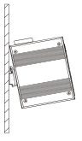
7.2 Din rail installation:
The first step is to check the grounding and stability of the guide rail: the guide rail slot of the switch is clamped into the guide rail; The second step: from the center to both sides of the guide rail positioning screws in order. Step 3: Use screws to fix the mounting rail card slot on the fixed guide groove at both ends of the guide rail to ensure that the guide rail and the switch are fixed on the guide rail vertically and stably.
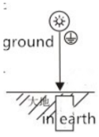
7.3 grounding
Fix the grounding wire to the grounding screw above the switch, and ensure good reliable connection of the grounding system.
7.4 Power Connection
Insert the power cord into the specified position of the 6-core terminal, and insert the terminal into the standard power supply inlet (P+1 and P-1 input corresponding to the first power supply P1, and P+2 and P-2 input corresponding to the second power supply P2). The available voltage standard of the power supply is supported from 12VDC to 52VDC
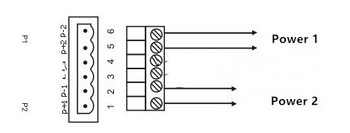

8. Packages
Content | QTY
Industrial switch | 1 PCS
User manual | 1 PCS

