TDMA 5.8G 900Mbps Wireless Bridge
Model: WB5acL8-Ex

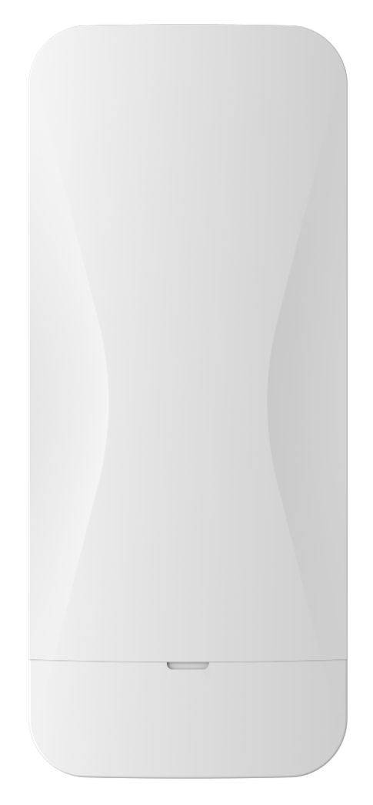

Description:
WB5acL8-Ex is a high-performance, high-speed outdoor long-distance wireless bridge. It has the characteristics of long transmission distance, strong penetration ability, and strong anti-interference ability..

Main Features:

- The use of specialized TVS lightning protection devices enhances the product's ability to withstand harsh environments.
- Built in 18dBi dual polarization directional antenna, up to 8km for PTP/ PTmP distance.
- Support non-standard frequency points: 4.9-6.1GHz.
- Support 5, 10MHz narrowband operating bandwidth
- Support ATPC, IPv6, TDMA.

Hardware Specification:

Model | WB5acL8-Ex
CPU | QCA9563+QCA9882+QCA8334
Flash | SPI NOR 16MB
DDR | DDR2-128MB
5G frequency | 5.150GHz～5.850GHz
5G WIFI protocol | 802.11 a / n /ac
Max rate | 900Mbps
Antenna | Internal 18dBi directional panel antenna
5G TX Power | 802.11a | 54M | 23±2dBm | 6M | 26±2dBm
5G TX Power | 802.11n HT20 | MCS7 | 22±2dBm | MCS0 | 26±2dBm
5G TX Power | 802.11n HT40 | MCS7 | 22±2dBm | MCS0 | 26±2dBm
5G TX Power | 802.11ac VHT20 | MCS9 | 21±2dBm | MCS0 | 26±2dBm
5G Receiving Sensitivity | 802.11ac VHT40 | MCS9 | 21±2dBm | MCS0 | 26±2dBm
5G Receiving Sensitivity | 802.11ac VHT80 | MCS9 | 21±2dBm | MCS0 | 26±2dBm
5G Receiving Sensitivity | 802.11a | 54M | -75dBm | 6M | -92dBm
5G Receiving Sensitivity | 802.11n HT20 | MCS7 | -72dBm | MCS0 | -90dBm
5G EVM | 802.11a_54M: ≤-25 dB；802.11n_MCS7: ≤-28 dB；802.11AC_MCS9:≤-32dB
ppm | ±20ppm
WAN | 1*10/100/1000M WAN, support 24V~48V passive POE
LAN | 1*10/100/1000M LAN
Power | PoE 24V passive POE, DC 12~24V
Max Power Consumption | <10W
Reset | Press 2-5 seconds for pairing, 10seconds for factory reseting.
Indicators | SYS, WAN, LAN, Signal*5
Dimension | 268mm*115mm*45mm
Weight | 0.48kg
Temperature | Working: -30°C to 55°C；Storage: -40°C to 70°C；Humidity: 5％～95％(Non-Condensing)
IP Grade | IP65
ESD | Air:±8K, Touch:±6K
Electrical Surge | Common Mode: 4K, Differential Mode: 2K

Firmware Specification
Working mode | Access Point (Automatic WDS), Access Point (TDMA3), Site (WDS/TDMA3), Site (ARPNAT)
Wireless | Intelligent dynamic polling, automatic channel selection, automatic modulation mode selection, automatic transmission power control (ATPC)
Wireless Safety | WPA/WPA2 personal encryption, WPA/WPA2 enterprise encryption, WACL, user isolation
Wireless QoS | TDMA implements 4 queue priority
Network mode | IPv4 IPv6
VLAN | Support VLAN and VLAN transparent transmission
WAN protocol | Static IP，DHCP client
Service | DHCP service, SNMP service, NTP client, route tracking, ping watchdog
Management | HTTP(S) GUI, SSH, SNMP read, WNMS, Telnet
Built Tool | Site survey, connection testing, antenna calibration

Antenna Specification
Horizontal polarization |  | Vertical polarization
 | 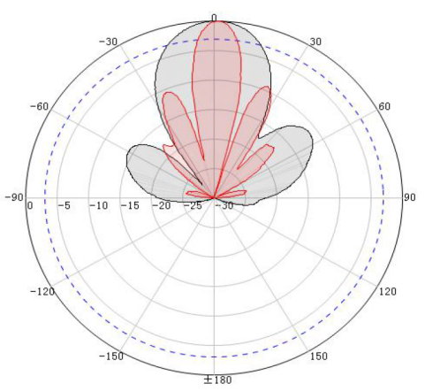 | 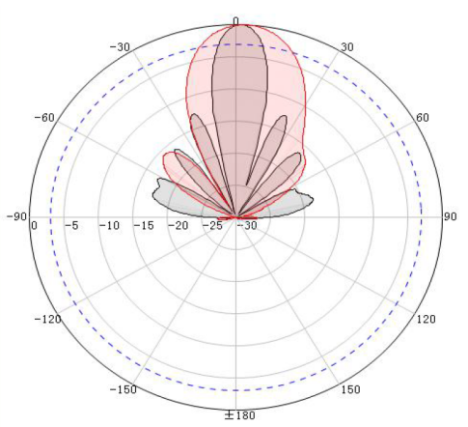

Built in Antenna
Working frequency | 5180 ~5850 MHz
Gain | 18 dBi
Polarization mode | Vertical/horizontal dual polarization
Horizontal beam angle | 30°
Vertical beam angle | 15°

Interface:
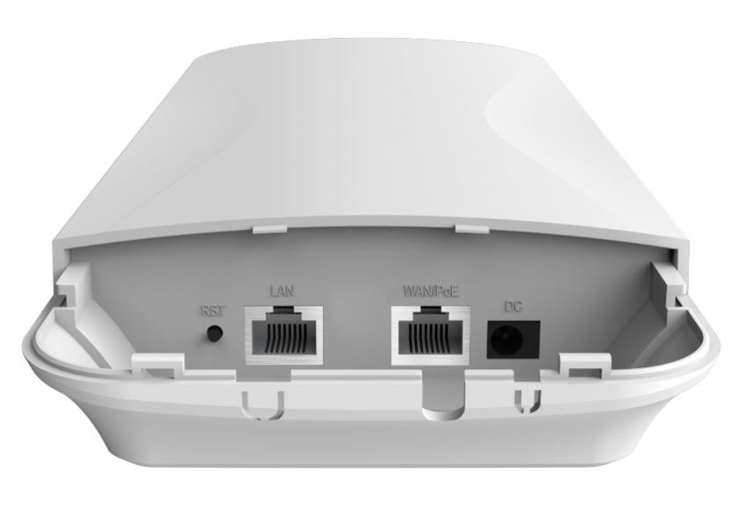
Dimension:
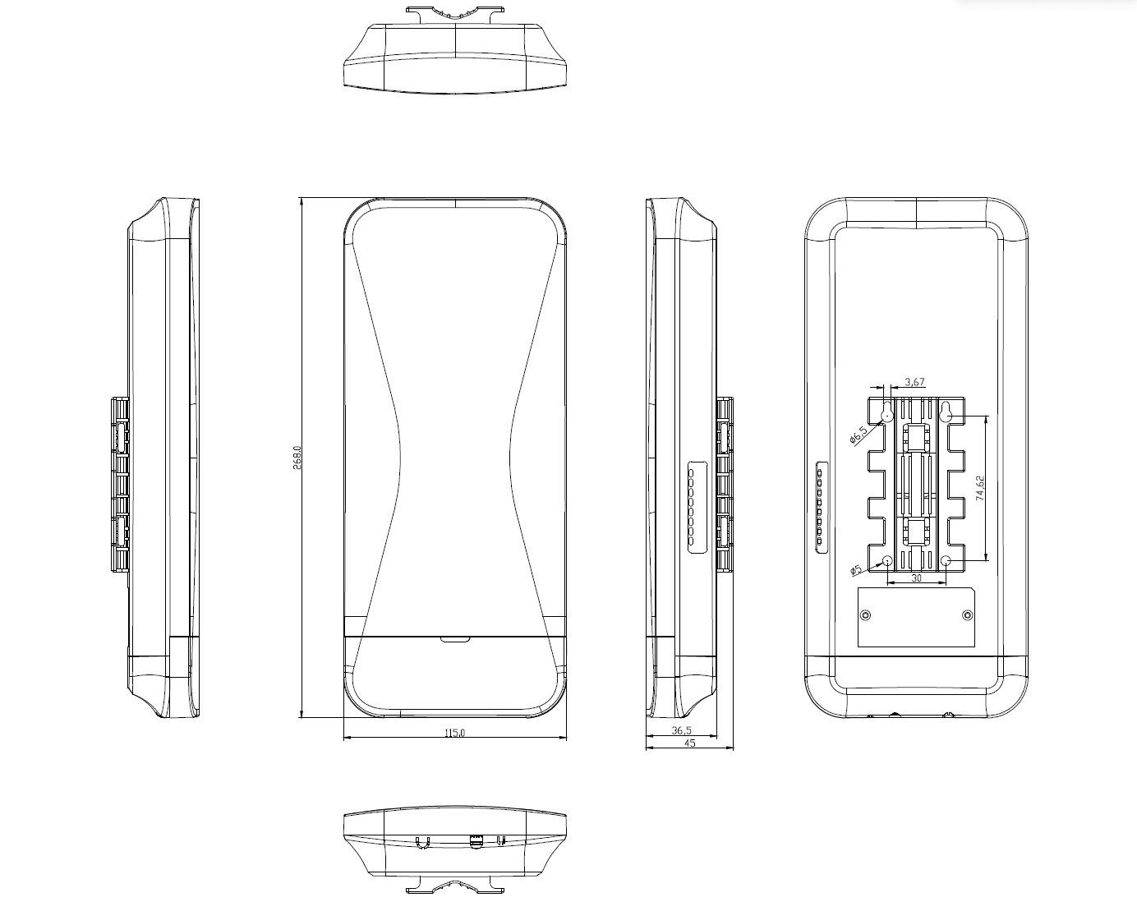

Accessory
CPE | 1
PoE adapter | 1
Gift Box | 1

