LBTD46G-SC2 LBTD46G-SC20 LBTD46G-SFP

6-port 10/100/1000BASE-TX+4-port 1000Base-FX Industrial Ethernet Switch
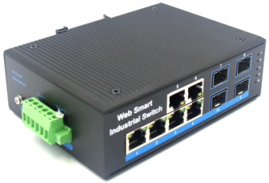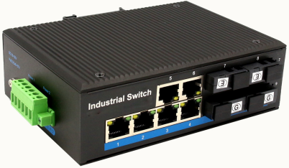
Interface
- 6-port 10/100/1000Base-Tx RJ-45 with auto negotiation and auto-MDI/ MDI-X function
- 4-port 1000Base-Fx interface SC/FC/ST/SFP
- Multi-Mode up to 2km
- Single-Mode up to 20km/40km/60km/80km

Industrial conformance
- 12V to 52V DC, redundant power input
- -40℃ to 80℃ operating temperature
- IP40 aluminum housing
- Supports 6KV DC Ethernet ESD protection
- Supports 6KV DC EFT protection for power line
- Free Fall, Shock and Vibration Stability
- DIN-rail and wall-mountable hardware design
Slim Type with more Practicability and Convenience
LBTD46G an hardened 6-port Industrial Ethernet Switch, provides non-blocking wire-speed performance in harsh industrial environment. It also provides 6-port 10/100/1000BASE-TX RJ45 +4-port 1000Base-Fx delivered in an IP40 rugged, strong case with redundant power system. Its slim case is suitable for such applications as surveillance system deployments, control management and wireless service in climatically demanding environments with wide temperature range from -40℃ to 80℃.

The LBTD46G series provides the flexibility to all kinds of 10/100/1000Mbps Ethernet Media on RJ-45 port and performs highly stable fiber performance.

The LBTD46G series is packaged in a compact IP40 case that allows either DIN rail or panel mounting to have efficient usage of cabinet space. It provides an integrated power supply with a wide range of voltages for worldwide operation. It also offers dual-redundant, reversible polarity 12V DC to 52V DC power supply inputs for high availability applications requiring dual or backup power inputs.

Specifications:
ROBOT
ROBOT
Model No. | LBTD46G-SC2 / LBTD46G-SC20 / LBTD46G-SFP
10/100/1000Base-TX Port | 6 port RJ-45 auto-MDI / MDI-X
1000Base-FX Port | LBTD46G-SC2: 4 SC interface  LBTD46G-SC20: 4 SC Interface  LBTD46G-SFP: 4 SFP Slot
Fiber Port Type | LBTD46G-SC2: SC / multi-mode ,up to distance 2km ;  LBTD46G-SC20: SC / single-mode ,up to distance 20km ;  LBTD46G-SFP: Vary on module
Optical Frequency | LBTD46G-SC2: 1310nm  LBTD46G-SC20: 1310nm  LBTD46G-SFP: Vary on module
Performance Specification | Bandwidth: 20Gbps  Packet Buffer Memory:2Mbit  Packet Forwarding Rate:15Mpps  MAC Address Table: 8K
Installation | DIN rail
Maximum Frame Size | 9000bytes packet size
Flow Control | Back pressure for half duplex, IEEE 802.3x pause frame for full duplex
Enclosure | IP40 aluminum housing
LED Indicator | Power: Red  Fiber: Link 2(Green)  Ethernet: Yellow
Power Input | 12 to 52V DC redundant power
Power Consumption | < 10watts
Surge protection | ±4KV
Network Protocols | IEEE802.3 10BASE-T;  IEEE802.3i 10Base-T;  IEEE802.3u;100Base-TX/FX;  IEEE802.3ab 1000Base-T;  IEEE802.3z 1000Base-X;  IEEE802.3x;
Network cables | 10BASE-T: Cat3,4,5 UTP(≤100 meter)  100BASE-TX: Cat5 or later UTP(≤100meter)  1000BASE-TX: Cat6 or later UTP(≤100 meter)
Industry Standard | FCC CFR47 Part 15,EN55032, Class A  IEC61000-4-2 (ESD): ±8kV (contact), ±12kV (air)  IEC61000-4-3 (RS): 10V/m (80~1000MHz)  IEC61000-4-4 (EFT): Power Port: ±4kV; Data Port: ±2kV  IEC61000-4-5 (Surge): Power Port: ±2kV/DM, ±4kV/CM; Data Port: ±2kV  IEC61000-4-6 (CS): 3V (10kHz-150kHz); 10V (150kHz-80MHz)  IEC61000-4-16 (Common mode conduction): 30V (cont.), 300V (1s)
Certification | CE FCC Rohs compliance
MTBF | 300,000hours
Dimensions (W x D x H) | 143.7 x 103.8 x 47.7 mm
Weight | Product Weight: 0.72KG  Packing Weight: 0.82KG
Working Environment | Working temperature: -40～80℃ ;  Storage temperature: -40～80℃  Relative Humidity: 5%~95 %( no condensation)
Warranty | 1-year replacement with new item; 3-years for main parts.
Dimensions
