LBT248GST4-SFP

24-Port gigabit SFP +8G RJ45 combo+4-Port 10G SFP

L3 Managed Industrial Switch
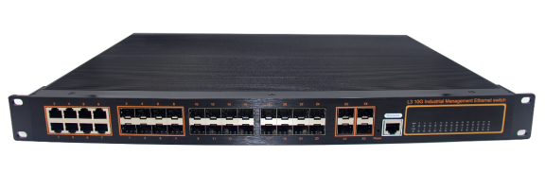

Rack mounted Aluminum Industrial Switch
Features
- Data control: support 802.3x full duplex flow control, support network storm suppression
- Redundant network: support STP/RSTP/MSTP, support ERPS (self-healing time <20ms)
- Support IPv6, static routing, Dynamic routing (RIP,OSPF)
- Support RIPng, OSPFv3, DHCP Server, DHCP replay, Qos
- Multicast management: Support IGMP Snooping V1/V2/V3
- VLAN: support IEEE 802.1q VLAN, effectively isolated broadcast domain
- Link aggregation: support link static/dynamic aggregation, provide perfect bandwidth utilization
- QoS: Support COS\DSCP, 4 queues, support WRR\SP scheduling mode
- Security management: support ACL access control list, support 802.1x, support user classification management
- Management function: support Web, SNMP management mode
- Monitoring maintenance: support port mirroring, interface status monitoring, log management
- Alarm function: support power supply, port, abnormal state relay output

LBT248GST4-SFP switch is a high performance 10G SFP+ L3 core switch. It provides Static routing and dynamic routing with advanced hardware processing capacity. The machine adopts modular design, which supports up to 4 Port 10G SFP+, and retains the expansion ability to further support 10GE when realizing gigabit convergence or access. It supports IPv4/IPv6 hardware double stack and line speed forwarding, so that customers can easily cope with the coming IPv6 era, which provides high capacity exchange capacity. LBT248GST4-SFP switch has the operating temperature of -40℃ ~ 85℃, has the super firmness to adapt to all kinds of harsh environment, can also be very convenient to install in the machine room cabinet. The rack-mounted characteristics and wide temperature operation make the switch a plug and play industrial-grade device, providing a reliable and convenient solution for users to network their Ethernet devices.

Strong processing ability
LBT248GST4-SFP switch is based on the powerful and stable
processing power of VCore-III MIPS-based CPU
LBT248GST4-SFP provides up to 598Gbps of switching capacity
port full speed filtering and forwarding 252Mpps
To ensure that the trunk network of large traffic data without blocking
Forwarding.

Specifications:
ROBOT
ROBOT
Model No. | LBT248GST4-SFP
Interface | 24-Port 10/100/1000Mbps SFP  8-Port 10/100/1000Mbps RJ45 (combo)  4-Port 10G SFP+  1-Port console
Performance Specification | Bandwidth(switch capacity): 598Gbps  Packet Buffer Memory:32Mbit  Packet Forwarding Rate: 252Mpps  MAC Address Table: 32K
Installation | Bracket mounted
Maximum Frame Size | 16360bytes
Flow Control | Back pressure for half duplex, IEEE 802.3x pause frame for full duplex
Enclosure | IP50 Aluminum housing
LED Indicator | Power: Red  Fiber: Link 2(Green)  Ethernet: Yellow
Dual Power Input | 36 to 72V DC &110～240V/50～60Hz AC
Power Consumption | < 45watts
Surge protection | ±4KV
Network Protocols | IEEE802.3 10BASE-T;  IEEE802.3i 10Base-T;  IEEE802.3u;100Base-TX/FX;  IEEE802.3ab 1000Base-T;  IEEE802.3z 1000Base-X;  IEEE802.3x;
Network cables | 10BASE-T: Cat3,4,5 UTP(≤100 meter)  100BASE-TX: Cat5 or later UTP(≤10meter)  1000BASE-TX: Cat6 or later UTP(≤100 meter)
Industry Standard  (EMC 4) | FCC CFR47 Part 15,EN55022/CISPR22, Class A  IEC61000-4-2 (ESD): ±8kV (contact), ±12kV (air)  IEC61000-4-3 (RS): 10V/m (80~1000MHz)  IEC61000-4-4 (EFT): Power Port: ±4kV; Data Port: ±2kV  IEC61000-4-5 (Surge): Power Port: ±2kV/DM, ±4kV/CM; Data Port: ±2kV  IEC61000-4-6 (CS): 3V (10kHz-150kHz); 10V (150kHz-80MHz)  IEC61000-4-16 (Common mode conduction): 30V (cont.), 300V (1s)
Certification | CE FCC Rohs compliance
MTBF | >300,000hours
Dimensions (W x D x H) | 442×325×44mm
Weight | Product Weight: 4KGS  Packing Weight: 4.15KGS
Working Environment | Working temperature: -40～85℃ ;  Storage temperature: -40～85℃  Relative Humidity: 5%~95 %( no condensation)
Warranty | 1-year replacement with new item; 3-years for main parts.

Dimensions
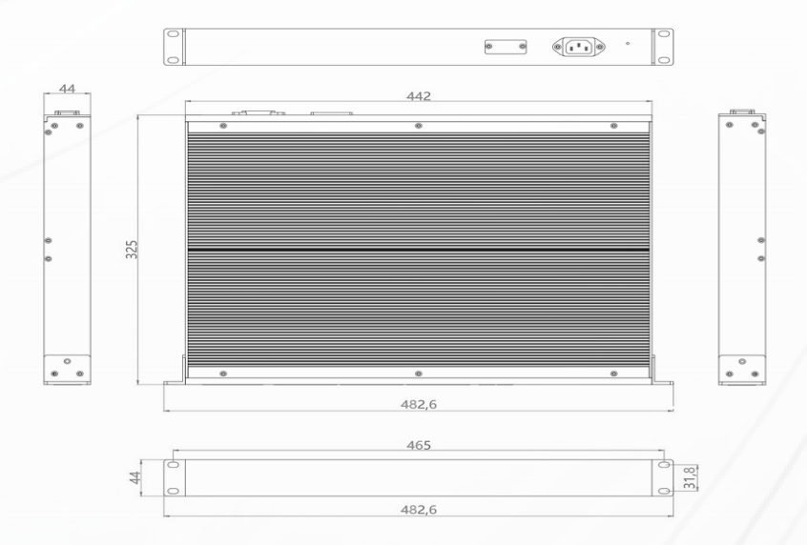

Ordering Information
LBT248GST4-SFP | 24-Port gigabit SFP +8G RJ45 combo+4-Port 10G SFP L3 Managed Industrial Switch

