
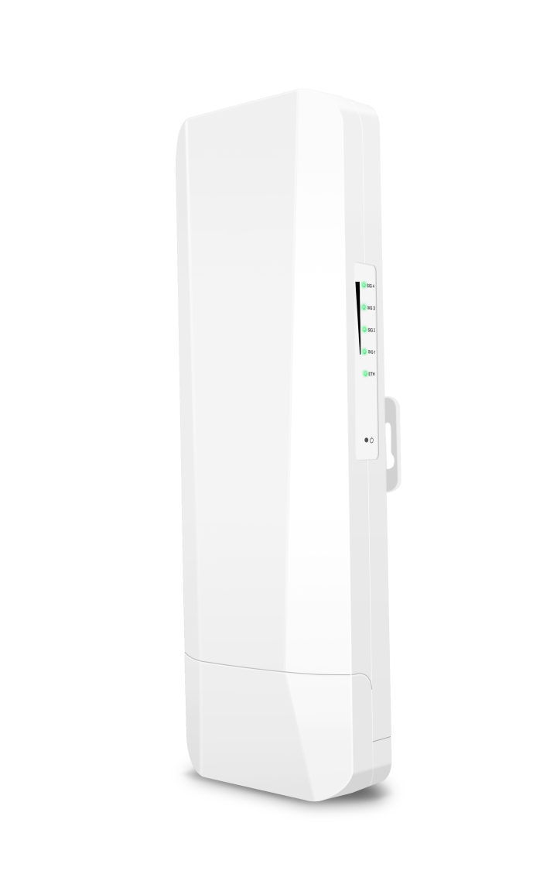
T300-N620
Third Generation Digital Bridge
  Product display  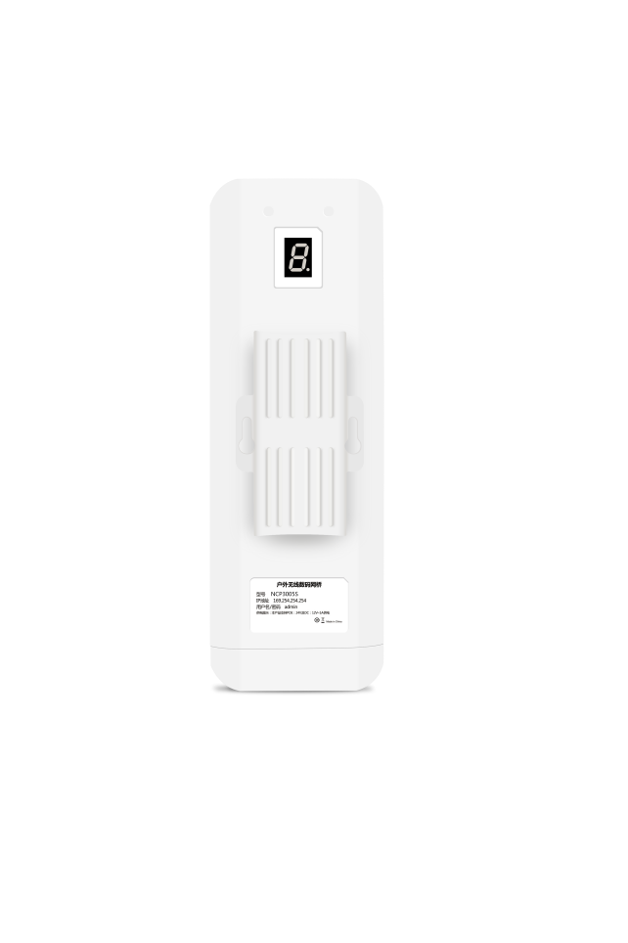  Schematic diagram | 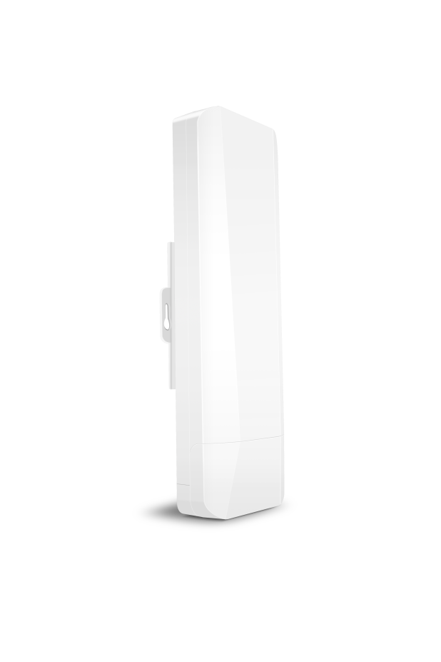
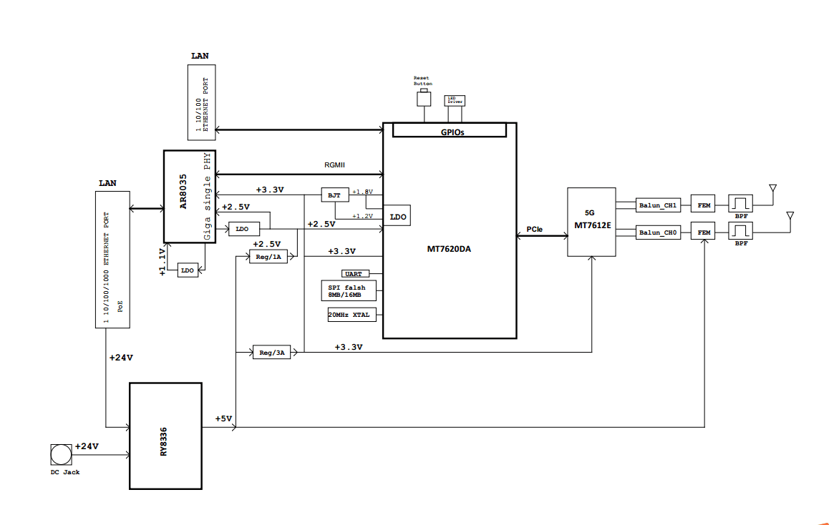

Product overview
T300-N620 is a high-performance enterprise outdoor bridge product that can support 5G full band and use 802.11a/N/AN/AC technology. The unique nixie tube pairing technology can easily complete the pairing of point-to-point and point-to-multipoint (within 8 points) devices without computer configuration. Gigabit network interface, 5G 802.11an MIMO technology wireless processing speed up to 900Mbps. The power supply mode is flexible, supporting 24V POE network cable power supply and 12V 1A DC local power supply, and the network cable power supply distance can reach 80 meters (related to the network cable material). It adopts outdoor IP65 windproof, rainproof, dustproof and sunscreen protection grade shell design, which can easily adapt to various outdoor harsh environments. Built-in 14dBi dual-polarization plate antenna for quick and easy installation. It has the characteristics of high performance, high gain, high receiving sensitivity and high bandwidth, which greatly enhances the performance and stability of wireless transmission and is widely used in short-distance video transmission and data transmission.
Product hardware features

- 900Mbps high speed and NAT high conversion rate
The N620 uses 802.11A/N/AN/AC technology to provide a wireless access speed of up to 900Mbps, which is about three times that of 802.11/B/G/n products in the same environment. At the same time, the conversion rate of NAT is more than 93%, so the download and upload speed through the external network is faster, and the Internet surfing is free.
- Transparent, energy efficient
The product supports IEEE802.3az, which allows a transceiver that has no frames to send to enter low-power mode, and when a new frame arrives, the transceiver returns to active mode within microseconds, thus achieving almost transparent power saving to the upper layer of the protocol. It can automatically adjust the energy consumption according to the actual flow of the port, and can quickly switch between full-speed operation and low-power idle mode, saving 30% of the power consumption for users and greatly saving the operation cost.
- Beamforming technology
The wave velocity shaping technology can automatically adjust the size of the signal weighted value of each array element in the array under the condition that the interference direction is unknown, so that the zero point of the antenna directional diagram is aligned with the interference direction to suppress the interference, enhance the detection capability of the useful signal of the system, optimize the antenna directional diagram, effectively track the useful signal, suppress and eliminate the interference and the noise, The interference can be successfully suppressed even in the case of multiple interferences distributed in a short distance and signals with the same frequency.
- Matching is simple and efficient
No need for network expertise, no need for computer operation, easy to dial and adjust the master and slave equipment nixie tube to the same value to complete point-to-point, point-to-multipoint (within 8 points) pairing work.
- Support 5G full frequency band
The supported channels are 36, 40, 44, 48, 52, 56, 60, 64, 149, 153, 157, 161, 182, 186, 190 and 194. Special channels are not enabled by default and can be enabled when necessary.

Main chip | MTK7620DA + 7612E includes 64M RAM
Flash memory | 8MB Flash
Size | 260*90*37mm
Antenna | 5.8G（802.11a/n/an/ac）2T2R
Antenna gain | Built-in dual-polarized high-gain 14dBi directional plate antenna
Speed | 5.8g 900Mbps
Port | One 10/100/1000Mbps RJ45 port, one 10/100Mbps RJ45 connector
Power source | Support DC 12V 1A, POE 24V 1A non-standard power supply
Button | 1 * Digital switch, short press the nixie tube to display the value plus one  1 * Reset button, press and hold for 5 seconds to restore factory settings  1 * Dial switch, left and right switch master-slave mode
Transmission distance | 2KM
Operating frequency band | 802.11 a/n/an/AC: 5.1GHz ~ 5.8GHz (China)
Transmitting power
  11a
  r6_24,r36,r48, | 23
  r54 | 20
  11AC VHT20
  MCS0, MCS1_2, MCS3_4, MCS5, MCS6 | 23
  MCS7 | 23
  MCS8 | 20
  MCS9 | 20
  11AC VHT40
  MCS0, MCS1_2, MCS3_4, MCS5, MCS6 | 23
  MCS7 | 20
  MCS8 | 20
  MCS9 | 20
  11AC VHT80
  MCS0, MCS1_2, MCS3_4, MCS5, MCS6 | 23
  MCS7 | 20
  MCS8 | 20
  MCS9 | 20
EVM | 11n  11ac
  MCS |  | Less than required (dB)
  Modulation | Coding rate | Less than required (dB)
  BPSK | 1/2 | -5
  QPSK | 1/2 | -10
  QPSK | 3/4 | -13
  16QAM | 1/2 | -16
  16QAM | 3/4 | -19
  64QAM | 2/3 | -22
  64QAM | 3/4 | -25
  64QAM | 5/6 | -28
  MCS |  | Less than required (dB)
  Modulation | Coding rate | Less than required (dB)
  BPSK | 1/2 | -5
  QPSK | 1/2 | -10
  QPSK | 3/4 | -13
  16QAM | 1/2 | -16
  16QAM | 3/4 | -19
  64QAM | 2/3 | -22
  64QAM | 3/4 | -25
  64QAM | 5/6 | -27
  256QAM | 3/4 | -30
  256QAM | 5/6 | -32
EVM
  5GHz | Symbol | Parameter |  | Rx(dBm)
  802.11a | Srf  (OFDM) | 1Rx chain | 6Mbps | -88
  802.11a | Srf  (OFDM) | 1Rx chain | 54Mbps | -72
  802.11ac | 802.11ac VHT20 | 1 Stream(1x1) | MCS0 | -84
  802.11ac | 802.11ac VHT20 | 1 Stream(1x1) | MCS7 | -67.5
  802.11ac | 802.11ac VHT20 | 1 Stream(1x1) | MCS8 | -64
  802.11ac | 802.11ac VHT20 | 2 Stream(2x2) | MCS0 | -83
  802.11ac | 802.11ac VHT20 | 2 Stream(2x2) | MCS7 | -66.5
  802.11ac | 802.11ac VHT20 | 2 Stream(2x2) | MCS8 | -63
  802.11ac | 802.11ac VHT40 | 1 Stream(1x1) | MCS0 | -82
  802.11ac | 802.11ac VHT40 | 1 Stream(1x1) | MCS7 | -65.5
  802.11ac | 802.11ac VHT40 | 1 Stream(1x1) | MCS9 | -58.5
  802.11ac | 802.11ac VHT40 | 2 Stream(2x2) | MCS0 | -81
  802.11ac | 802.11ac VHT40 | 2 Stream(2x2) | MCS7 | -64.5
  802.11ac | 802.11ac VHT40 | 2 Stream(2x2) | MCS9 | -57.5
  802.11ac | 802.11ac VHT80 | 1 Stream(1x1) | MCS0 | -79
  802.11ac | 802.11ac VHT80 | 1 Stream(1x1) | MCS7 | -62
  802.11ac | 802.11ac VHT80 | 1 Stream(1x1) | MCS9 | -55.5
  802.11ac | 802.11ac VHT80 | 2 Stream(2x2) | MCS0 | -78
  802.11ac | 802.11ac VHT80 | 2 Stream(2x2) | MCS7 | -61
  802.11ac | 802.11ac VHT80 | 2 Stream(2x2) | MCS9 | -54.5
Support rate | 802.11ac: 6.5Mbps-867Mbps  802.11n: 6.5Mbps and 300Mbps
Operating/storage temperatures | -Temperature: -30 ℃ ~ + 55 ℃ (working), -40 ℃ ~ + 70 ℃ (storage)  Humidity (non-condensing): 10% ~ 90% (operating), 5% ~ 95% (storage)
Waterproof grade | IP65
Signal indicators, 4 | Bridge Access Point: Output Power Indicator  Below 25% (SIG1 always on), 25% ~ 50% (SIG1-SIG2 always on), 50% ~ 75% (SIG1-SIG3 always on),  75% ~ 100% (SIG1-SIG4 are always on).  Bridge client: connection signal strength indicator  When the connection fails, the water lamp will be turned on. When the connection is successful:  0 ~ -65dBm (SIG1-SIG4 is normally on), -66 ~ -75 dBm (SIG1-SIG3 is normally on), -76 ~ -85dBm (SIG1-SIG2 is normally on), signal strength below -86 dBm (SIG1 is normally on)
LAN1 | Gigabit network port status indicator: Flashes when wired data is transmitted, and goes out when wired data is disconnected.
 | Wireless light: Flashes when the bridge is powered on and operating normally
 | Power indicator: it is normally on when the power is on, and it is off when the power is off.

