Content
Log into the Switch Web Interface 3
Switch Information 4
Global Information 4
Statistical Information 6
Log Information 6
Alarm List 6
Port Management 7
Port Configuration 7
Port Isolation 8
Mirroring Port 8
Rate Limited 8
Storm Control 9
Port Energy Saving 9
PoE 10
PoE Port Configuration 10
Devices Power Supply 10
Timing Power Supply Configuration 11
Intelligent Power Supply Configuration 12
L2 Management 12
MAC address table 12
VLAN Configuration 13
GVRP 16
Link Aggregation 17
MSTP Configuration 19
Loop Protection 21
DHCP-snooping 22
IGMP Snooping 23
802.1x authentication 24
Senior Management 27
QOS Configuration 27
ACL Configuration 27
SNMP Configuration 29
RMON 31
LLDP Configuration 32
NTP Configuration 33
Anti Attack 34
System Management 34
User Settings 34
Network Settings 35
Alarm Configuration 35
Service Configuration 36
Configuration Management 36
Firmware Update 36
Diagnostic Testing 37
Reboot Device 38

Log into the Switch Web Interface
The default management address of the switch is 192.168.10.12/24, when logging into the web management page of the switch, you need to set the IP address of the local network card and the IP address of the switch are in the same segment, as shown in the following screen: the IP address of the local network card is set to 192.168.10.222/24.
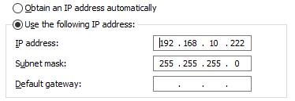
Enter the management address of the switch in the search bar of the browser, screen as below:
Confirm to enter the web verification page of the switch.
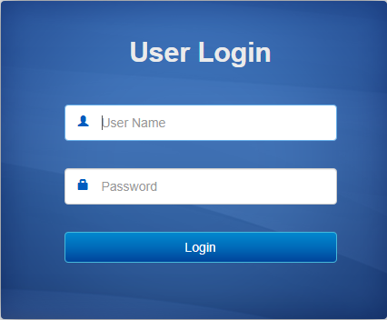
User Name: admin
Password: admin.
Click login to login to the web interface of the switch.

Switch Information
This module is used to view the internal data of the switch when it is running, including the flow rate of the port, the working mode, and the log information of the switch.

Global Information
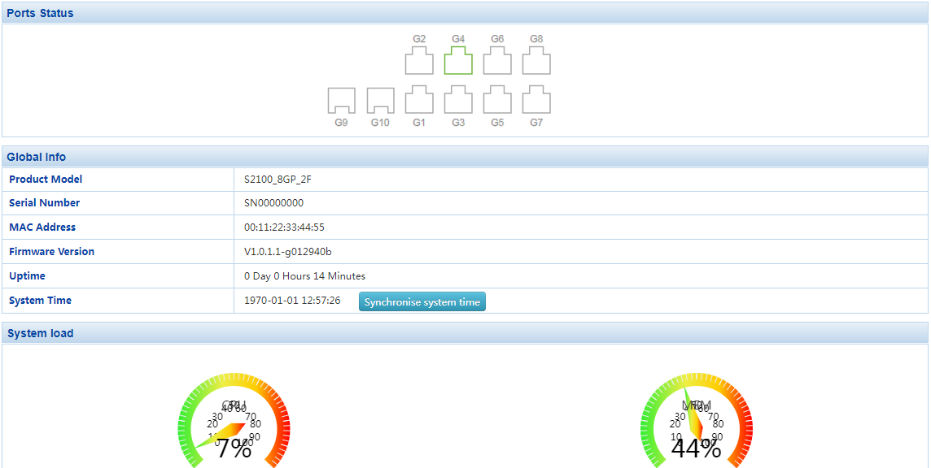
The following functions are in included:
View the current port status, port working mode and port speed of the switch. Move the mouse to the 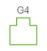 icon and he port name, status, bandwidth, duplex mode, and rate will be displayed.
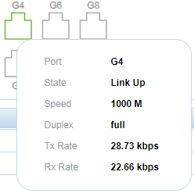

indicates that the port has been enabled and the connection has been established,  indicates that the port is not enabled, and  indicates the optical port.
View the switch property information, click in the page to synchronize the local computer time with the system time of the switch.
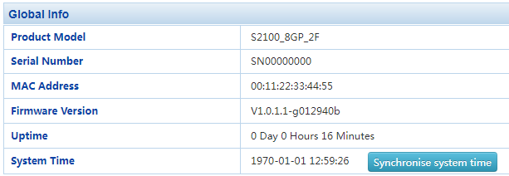
To check the CPU and memory usage of the switch.
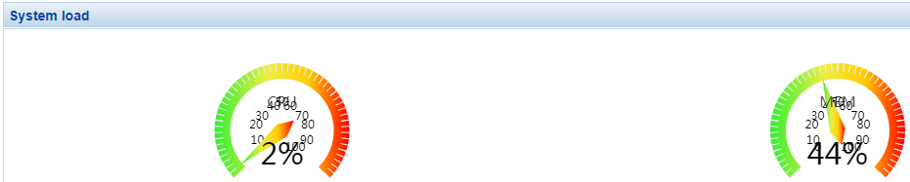

Statistical Information
To check the message data received and sent by various ports, including Basic Packet Statistics, Detailed Packet Statistics, MAC Frame Length Statistics and MAC Frame Error Statistics.
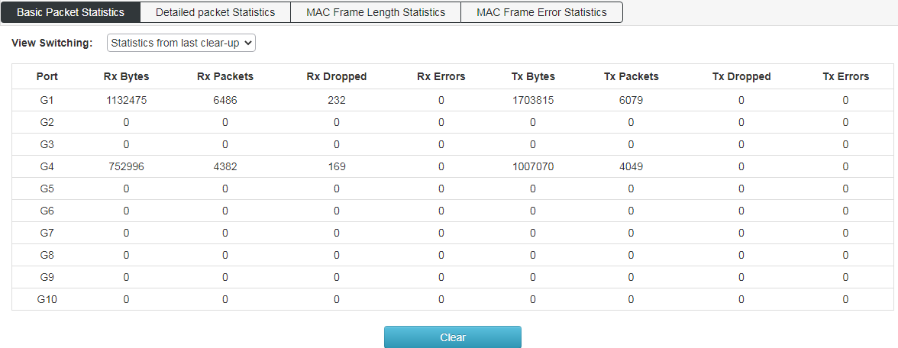

Log Information
Log is used to view simple switch log, and can view switch startup and port startup data, screen as blew:
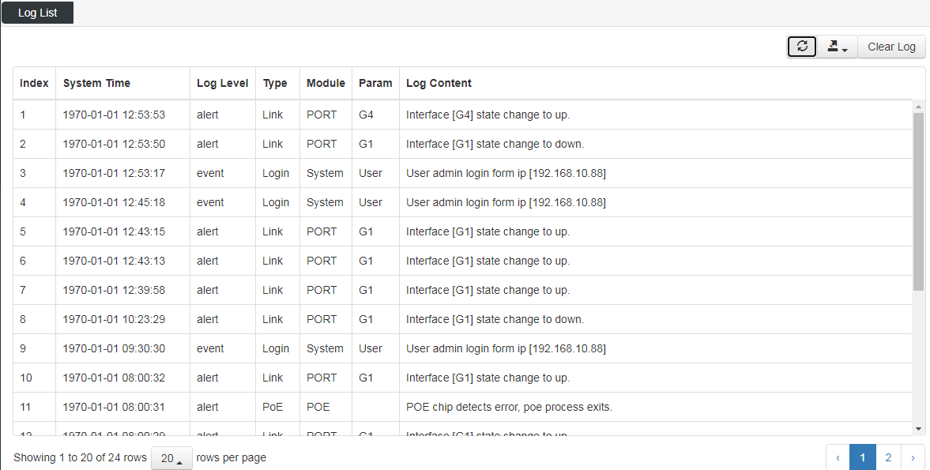

Alarm List
This page is used to view the alarm information of the switch;
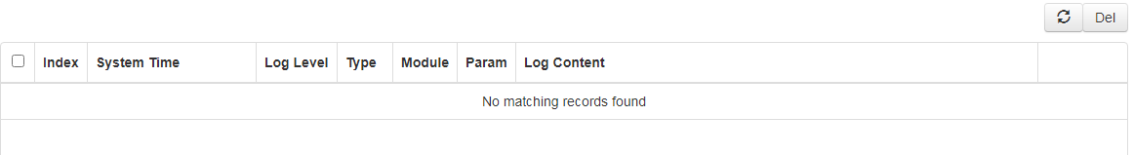

Port Management

Port Configuration
In this page, you can set the port rate, duplex mode, the max frame length (the value range is 1518-10240), flow control and switch port.
In the link status, indicates that the port is not connected, or the port has been manually down. When the link status is or , it indicates that the port is working normally, the color is the port working mode (green is Gigabit, yellow is 100MB).
On this page, you can not only view the port link status and port working mode, but also set the port working mode, such as "100MB full / half duplex", "Gigabit full / half duplex" and "adaptive". You can also close the specified port through this page, which is the same as the command “shut down”.
For the frame size setting, the default is basic frame 1522, which can be modified to super long frame 9600. The value range of this item is 1518-10240.
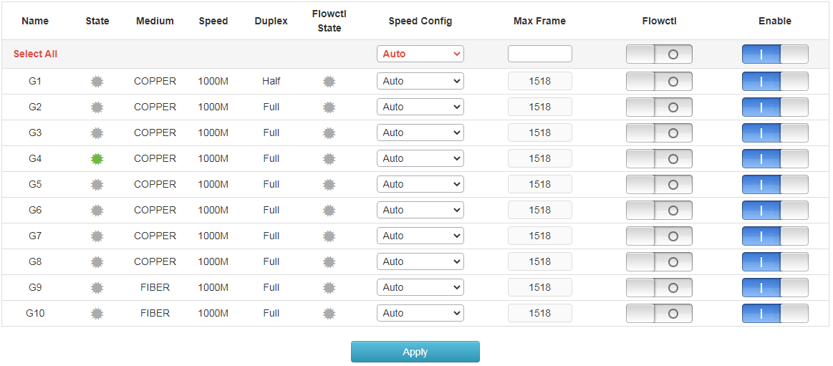

Port Isolation
This page is used to configure the port isolated. The isolated ports cannot communicate with each other, and the isolated ports can communicate with other non isolated ports.
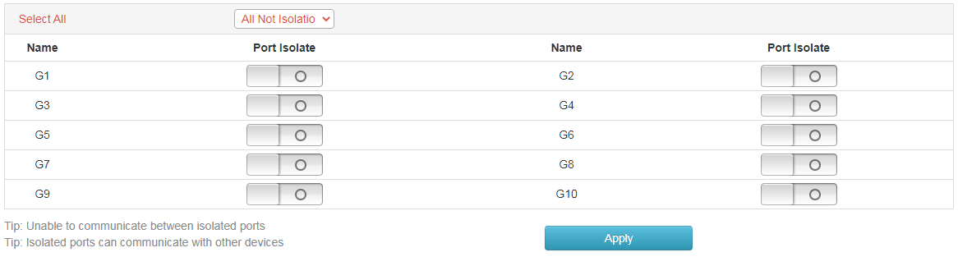

Mirroring Port
This page is used to configure the mirror port, 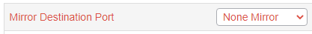 is used to configure to accept mirror data； is used to configure all port mirroring properties in one step.
The configuration representative in the following page mirrors the sent message data of port 4 to port 1, screen as blew:
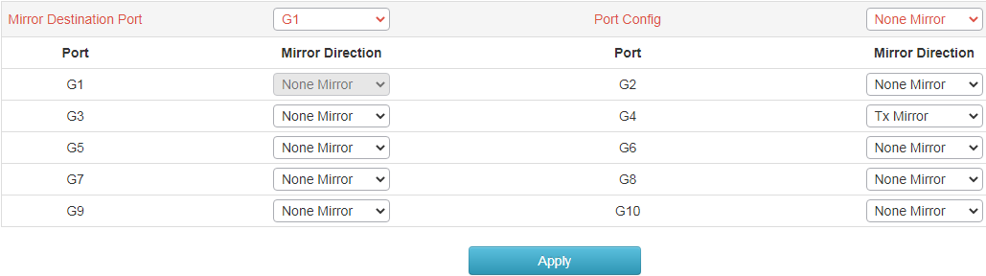

Rate Limited
This page is used to limit the upper limit of port rate;
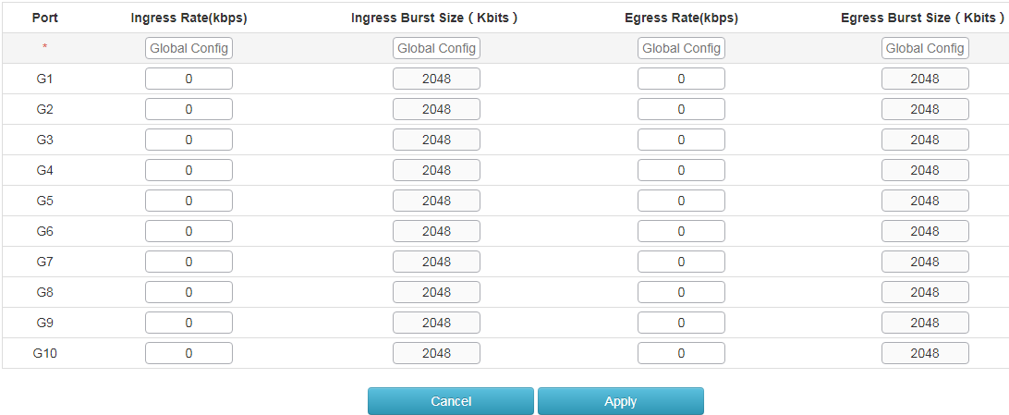

Storm Control
This page is used to limit the packet rate of port broadcast, multicast and unicast,
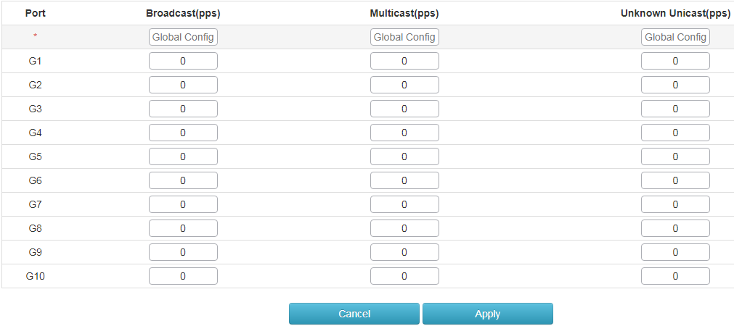

Port Energy Saving
This function is used to open the energy saving mode of switch port, screen as blew:
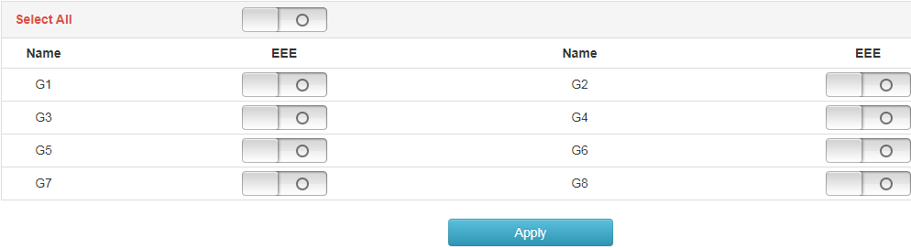

PoE

PoE Port Configuration
You can view the working status of the port PoE and the current voltage and current data provided, screen as blew:
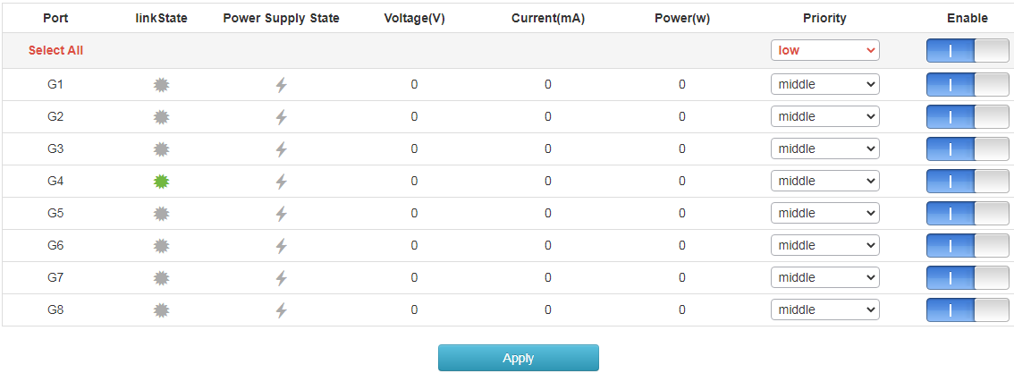
In the link column of the page, indicates that the port has no data transmission, indicates that the port is in forwarding state, in the power supply status column indicates that the port is not PoE powered, and indicates that the port is in PoE power supply state. The voltage, current, and power columns respectively display the voltage, current and power provided by the POE power supply port. The priority column is used to change the PoE power supply priority of the switch port. When the overall power is insufficient, the port with higher priority will give priority to power supply. The startup bar is used to enable the port PoE function.

Devices Power Supply
This page is used to set the total output power of the switch, with a value range of 60 ~ 300W. It can also be used to view the total output power and chip temperature of the current switch.
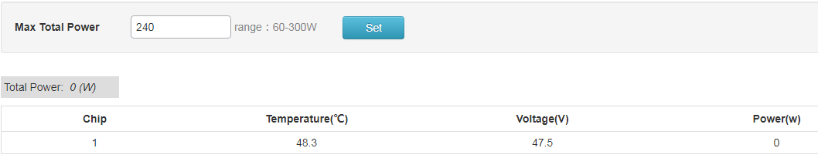

Timing Power Supply Configuration
Configure the periodic outage period or specific outage time of the switch.
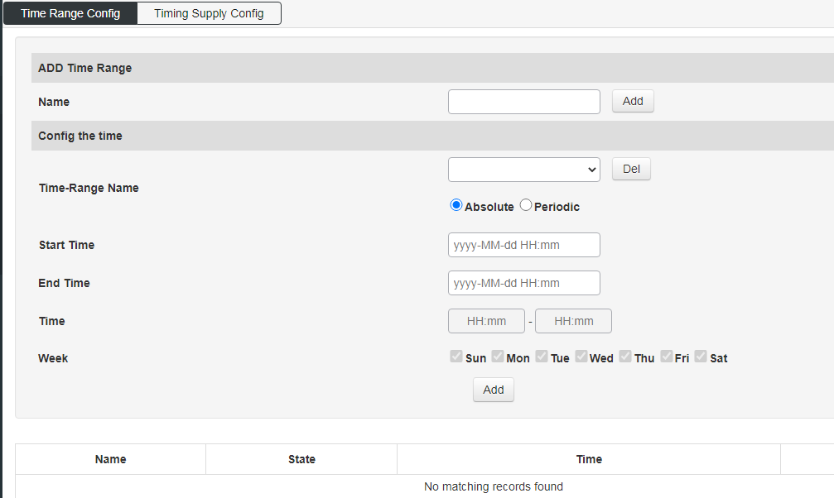
Apply the set power-off time to the port, and turn on this function by default for all ports.
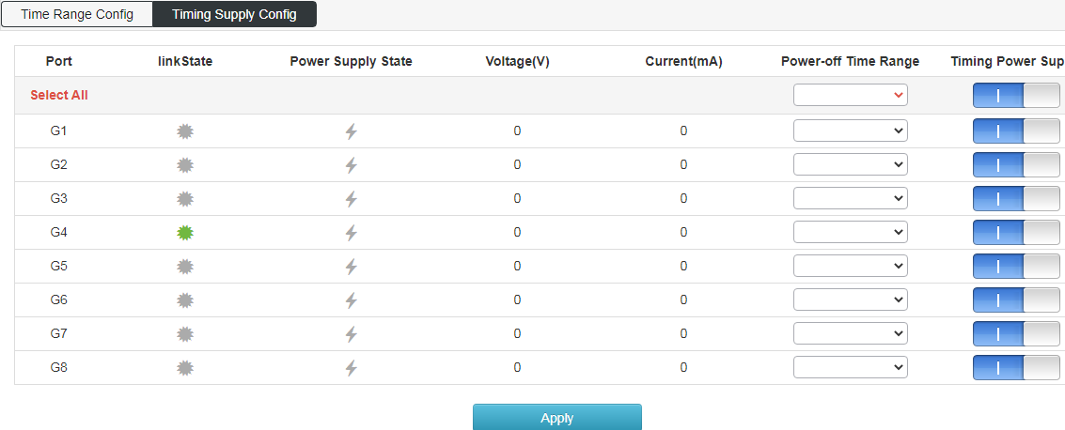

Intelligent Power Supply Configuration
Set PoE port to automatically disconnect power supply when there is no data transmission within a certain period of time. The default value is that when there is no data transmission in 120 seconds, the POE port will disconnect the power supply, and the value range is 60 ~ 600 seconds.
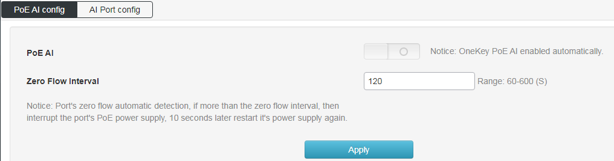
Open the port intelligent power supply function, which is all on by default.
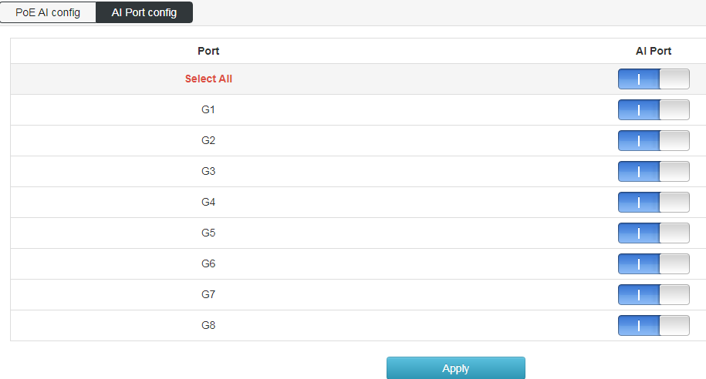

L2 Management

MAC address table
Check the MAC address of the device mounted on the switch
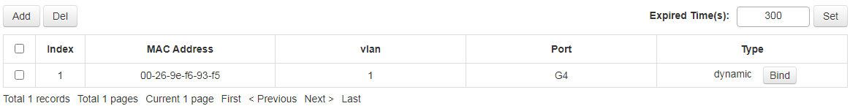

VLAN Configuration
This page includes viewing VLAN State, VLAN Configuration, Voice VLAN Configuration, MAC VLAN configuration and IP VLAN configuration.
Screen as blew:
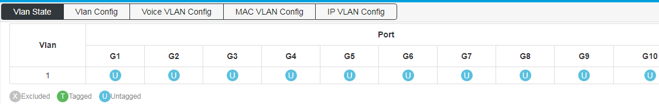
The screen below shows the configuration of port VLAN;
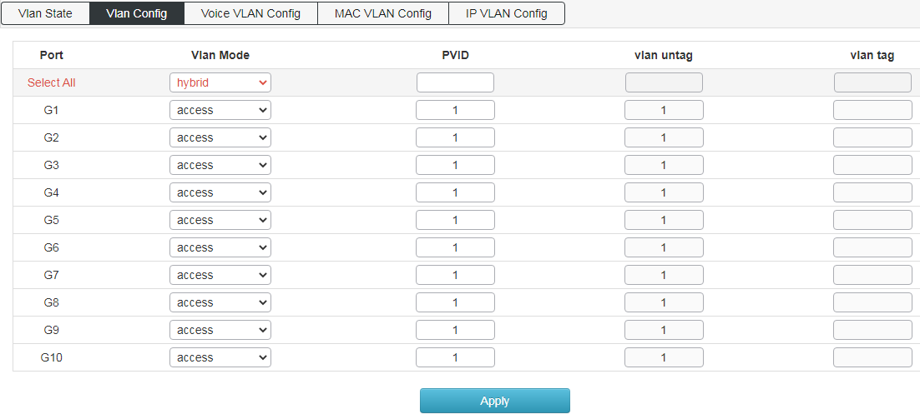
Port properties that can be set:
Access：
Access ports are normally used to connect to end stations. Dynamic features like voice VLAN may add the port to more VLANs behind the scenes. Access ports have the following characteristics:
•Member of exactly one VLAN, the Port VLAN (Access VLAN), which by default is 1.
•Accepts untagged and C-tagged frames.
•Discards all frames that are not classified to the Access VLAN
•On egress all frames classified to the Access VLAN are transmitted untagged.
The access port is usually used to connect to the terminal station. For example, the dynamic characteristics of voice VLAN can add ports to multiple VLANs behind the scenes. The access port has the following characteristics:
•There is only one VLAN, port VLAN (also known as access VLAN), which is a member of 1 by default.
•accept unlabeled frames and C-labeled frames,
•Drop all frames in unclassified access VLAN,
•All frames to the exit are sent unmarked.
Trunk：
The trunk port can traffic multiple VLANs at the same time and is usually used to connect to other switches. The trunk port has the following features:
• by default, the trunk port is a member of all existing VLANs. This can be achieved by using a limited number of VLANs.
•Unless enabled on the port of VLAN relay, divided into different VLANs, and the frame of that the port is not a member will be discarded.
•By default, all frames, but VLAN (also known as local VLAN) frame tags classified into ports get about exits. The frames classified to the port VLAN do not get the exit of c-tag,
•The exit marker can change all frames of the marker, in which case only the entry of the marked frame is accepted,
•VLAN trunking may be enabled.
Hybrid：
The hybrid port is similar to the trunk port in many ways, but adds additional port configuration capabilities. In addition to the characteristics described for the relay port, the hybrid port also has the following capabilities:
•It can be configured as VLAN tag or unknown, C-tag all, S tag all, or S-custom tag all.
•The inlet filtration can be controlled.
•The exit annotation and configuration of the access frame can be configured independently.
Port VLAN: Determine the VLAN ID (also known as PVID) of the port. The allowable VLAN range is 1 to 4095, and the default is 1.

Voice VLAN configuration’s screen as blew:
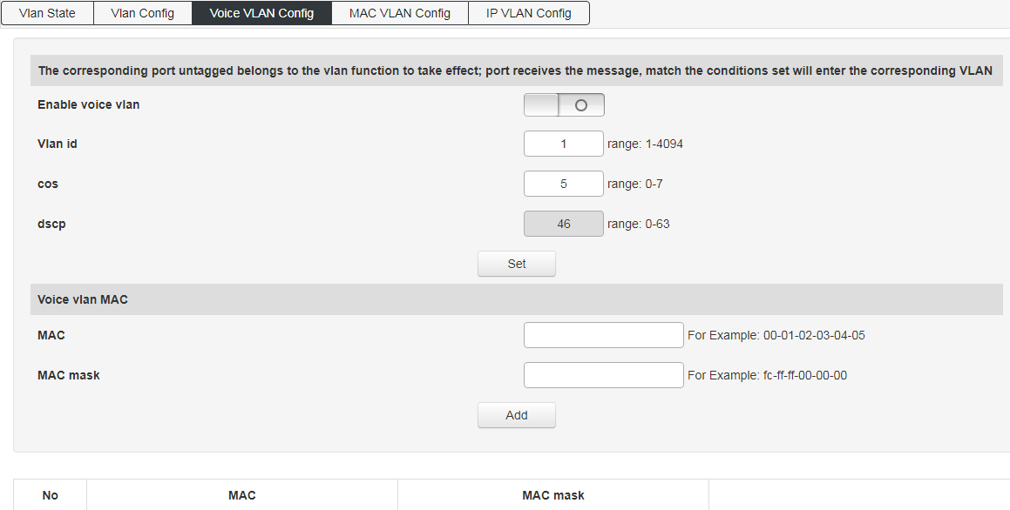
Enable Voice VLAN, the Access port will carry the IP voice traffic from the IP phone. When the switch is connected to Cisco IP phone (such as Cisco 7960 IP phone), the voice traffic sent by IP phone has three layers of IP priority and two layers of CoS value, which are set to 5 by default. For IEEE 802.1Q or IEEE 802.1p tagged traffic, the default cos value is untrusted.
Configure VLAN based on MAC address, screen as blew:
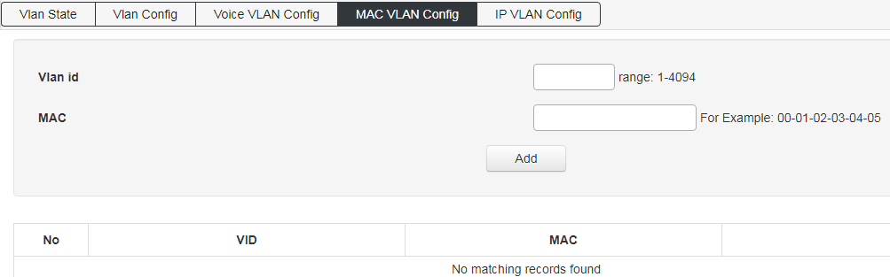
Configure VLAN based on IP, screen as blew:
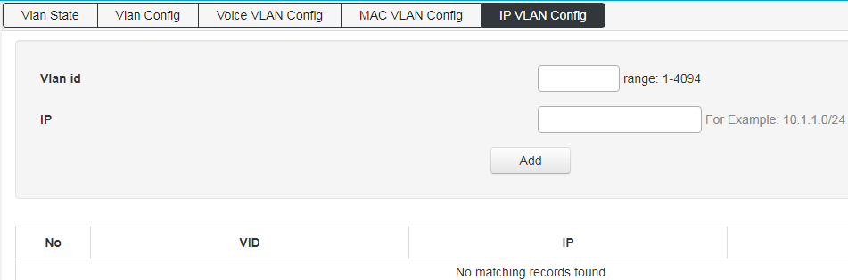

GVRP
Enable the GVRP function, screen as blew:
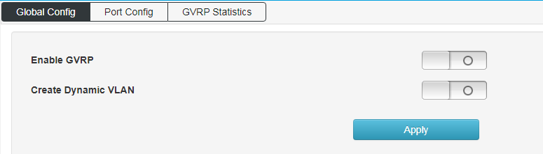
The enabled GVRP function is applied to the designated port and configure its timer.
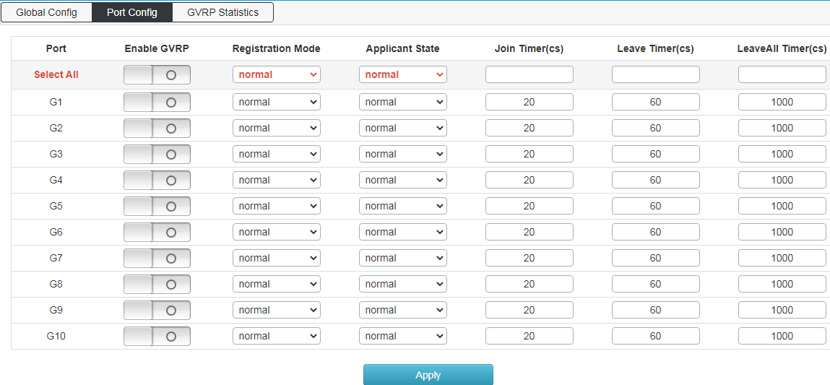
Used to view the operation information of GVRP.
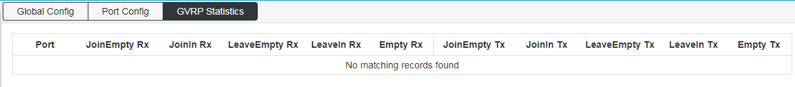

Link Aggregation
On this page, you can configure static aggregation groups, dynamic aggregation groups, and view link aggregation information;
Static aggregation configuration: click create static aggregation group TID value range is (1-4), that is, up to 4 static aggregation groups can be created.
Port Member: Port join aggregation must be the same speed and full duplex
This switch supports 32 groups of aggregation, each group supports up to 8 ports. To configure an aggregation group, just select the convergence port to the same line group number, as shown in Figure 21: 1-2 ports converge in a group; 3-4 ports in a group. Please keep configuration consistency for the ports of aggregation group members, such as port rate mode, VLAN information, etc.
Link aggregation load balancing mode supports:
"Source MAC address" (load balancing calculation based on source MAC address of message)
"Destination MAC address" (load balancing calculation based on the destination MAC address of the message), "
"IP address" (the source IP address and the destination IP address of the message are XOR, and then the load balancing calculation is performed)
"TCP / UDP port number" (load balancing calculation is based on the TCP / UDP port number of the message).
Four modes can be selected and combined. The assignment of equalization algorithm is global.
If LACP dynamic aggregation protocol is enabled on some ports, static aggregation cannot be configured manually.
Note:
Static aggregation on the same port cannot be configured simultaneously with dynamic LACP aggregation.
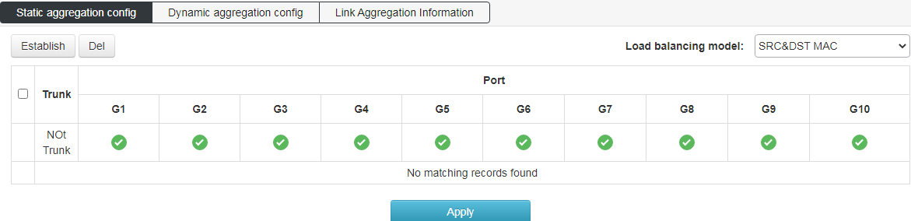
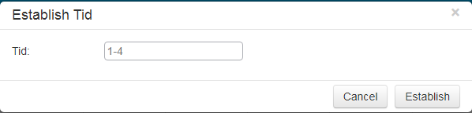
Configure dynamic aggregation port as blew:
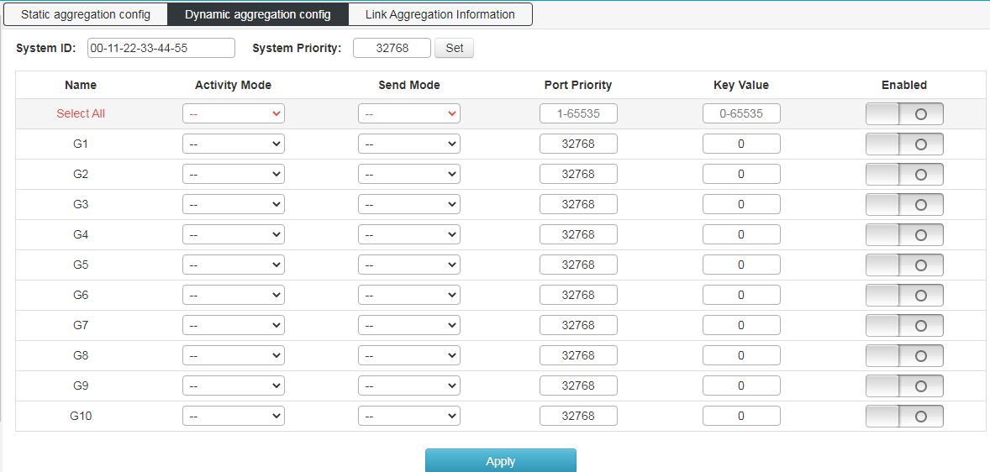
Link aggregation information: view switch aggregation port information.
The switch supports port dynamic aggregation. After enable the dynamic protocol of the port, the devices on both sides of the convergence exchange information through the protocol. According to the parameters and status of both sides, the matching links are automatically gathered together to send and receive data. After the convergence is formed, the switching equipment maintains the convergence link state, and automatically adjusts or disbands the aggregation link when the configuration of both sides changes.
The configuration parameters of dynamic protocol include protocol switch state, key negotiation and active / passive mode selection. Only when the dynamic protocol is turned on can the dynamic negotiation be carried out, which may lead to the formation of aggregation links. The key is the basis of negotiation. Only the ports with the same key can negotiate to form an aggregation link. The negotiation mode is "active | passive". When "active" is selected, the device will actively initiate aggregation negotiation; when "passive" is selected, the device will passively accept the aggregation negotiation initiated by other devices. If some ports have been converged statically, the dynamic convergence of LACP cannot be realized.
Note: dynamic LACP aggregation and static convergence on the same port cannot be configured at the same time
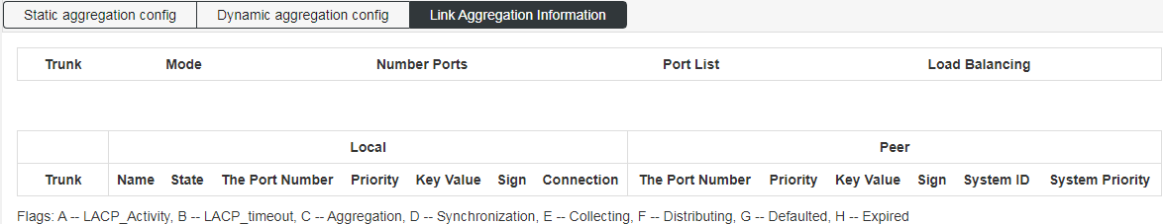

MSTP Configuration
Global configuration: select the spanning tree protocol version (STP / RSTP / MSTP is optional), MSTP protocol is selected by default.
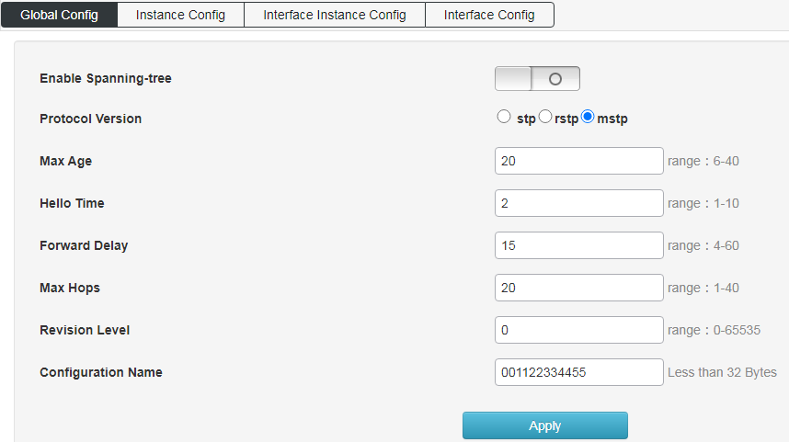
An example of configuring MSTP:
Set the mapping VLAN of multi spanning tree.
Configuration name: identifies the name of the VLAN to MSTI mapping, the bridge must share the name and revision (see below), and the VLAN-to-MSTI mapping configuration in order to share the MSTI spanning tree. (within region) the name is up to 32 characters.
Configuration version: revision of MSTI configuration above. It must be an integer between 0 and 65535.
Mapped VLANs: a list of VLANs mapped to MSTI. VLANs must be separated by commas and / or spaces. VLAN can only be mapped to one MSTI. An unused MSTI should remain empty. (that is, no VLAN is mapped to it).
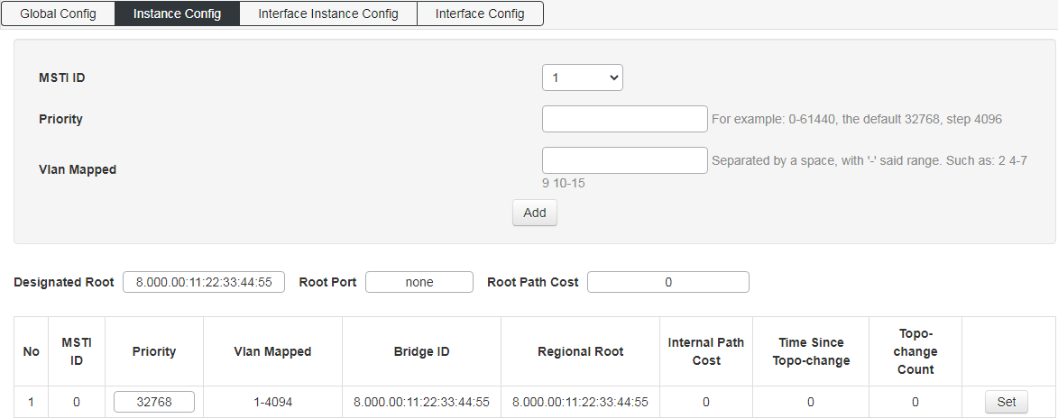
Interface instance configuration: configure the enable of the instance on the port. Screen as blew:
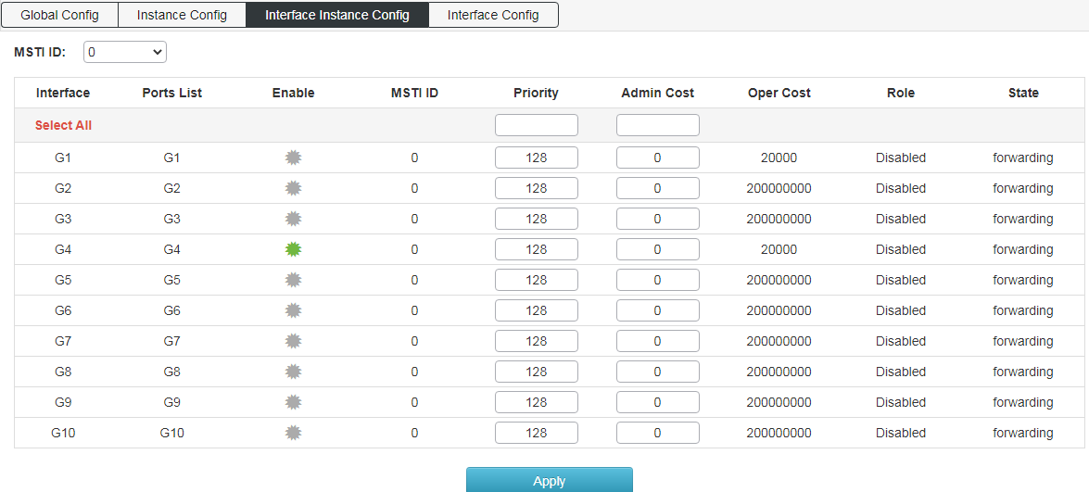
Interface configuration: configure the enabled port of spanning tree protocol and the enabled port of BPDU message. Screen as blew:
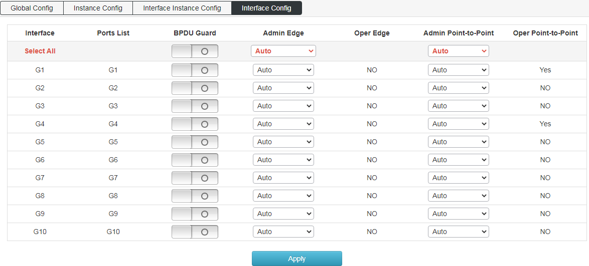

Loop Protection
Global Configuration: enable and set loop protection, screen as blew:
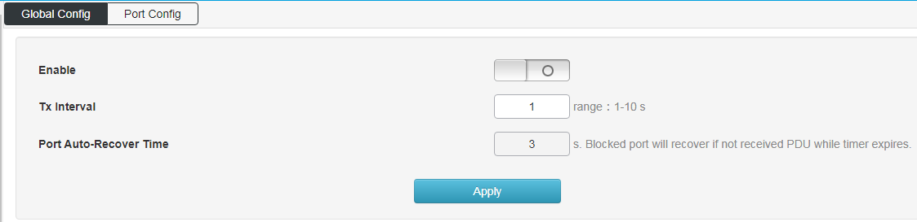
Port Configuration: enable the loop protection function on the port.
The loop protection includes double fiber ring protection and four fiber ring protection.
The unidirectional ring is usually composed of two optical fibers, one of which is the working fiber, represented by S; the other is the protective fiber, represented by P. Protection switching is accomplished by a reverse switch.
In addition to the unidirectional switching ring, there are also bidirectional multiplexer switching double fiber ring and bidirectional multiplexing segment switching four fiber ring. But the analysis shows that the unidirectional path switching double fiber ring is the best considering the node cost, system complexity and product compatibility.
The working mode is divided into recovery mode and non recovery mode. In the recovery mode, when the working section has recovered from the failure state, the working path automatically switches back to the working section. In the non recovery mode, even if the working section has been restored to normal, the working path is still unchanged in the protection section. Generally, 1 + 1 protection can work in both recovery mode and non recovery mode, while 1: N protection can only work in recovery mode.
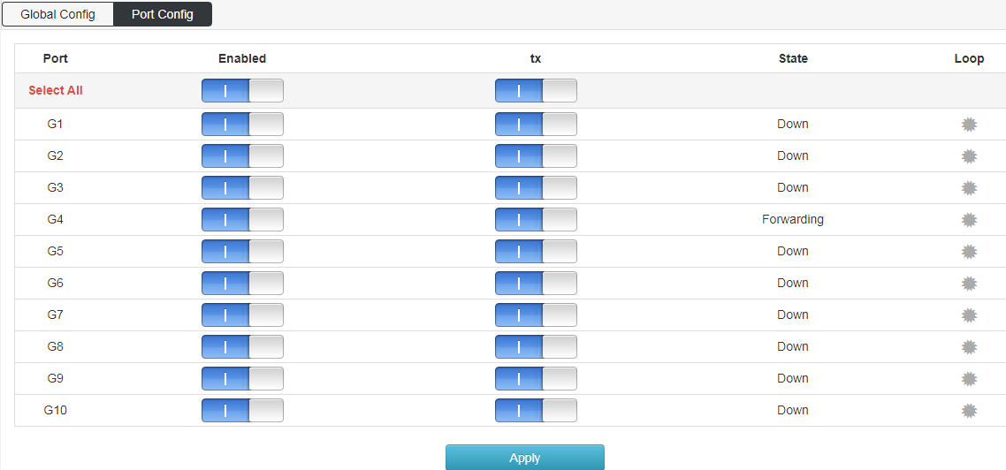

DHCP-snooping
Global configuration: enable DHCP monitoring function, screen as blew:
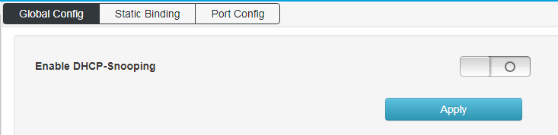
Static Binding: configure the static listening port, screen as blew:
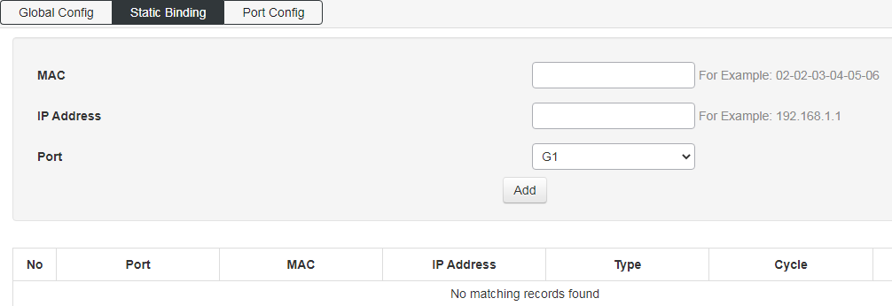
Port Configuration: enable DHCP monitoring function on the port, screen as blew:
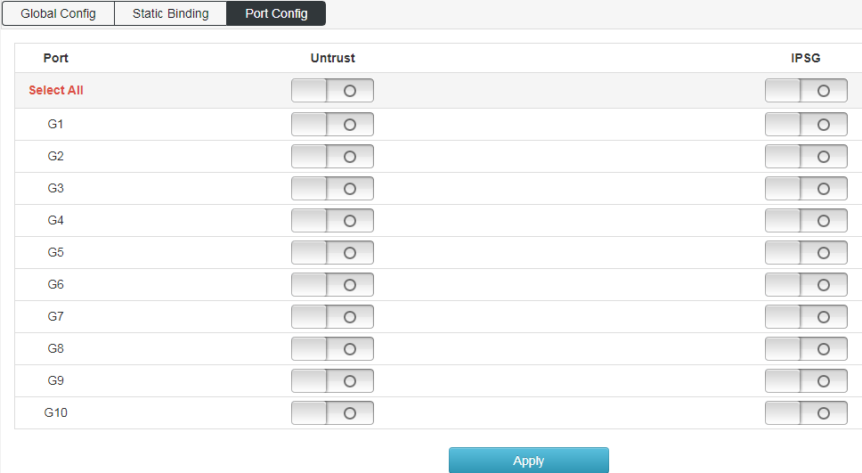

IGMP Snooping
IGMP snooping global configuration: configure IGMP monitoring enable and IGMP function attributes, screen as blew:
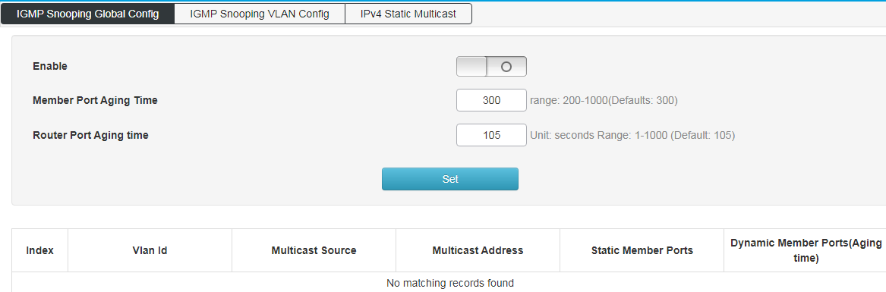
IGMP snooping VLAN configuration: configure static multicast VLAN, screen as blew:
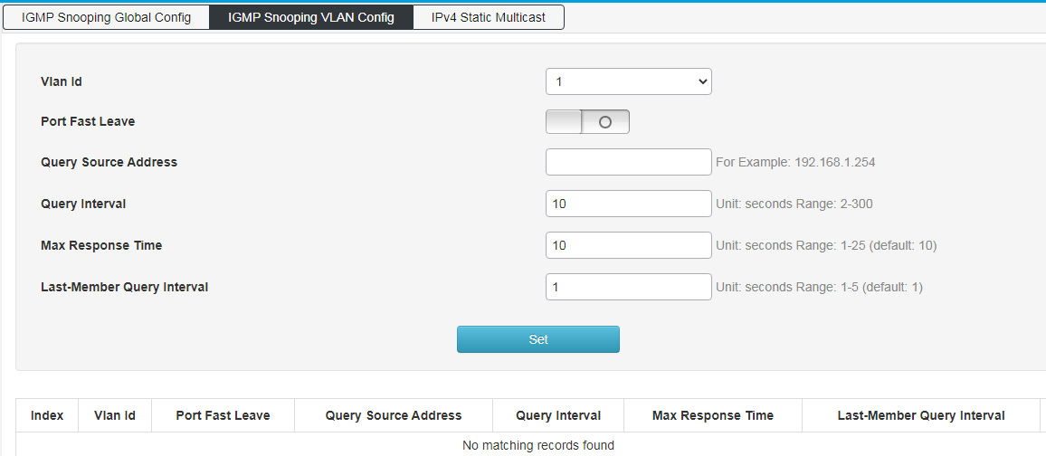
IPv4 Static Multicast: configure static multicast function and enable port static multicast function, screen as blew:
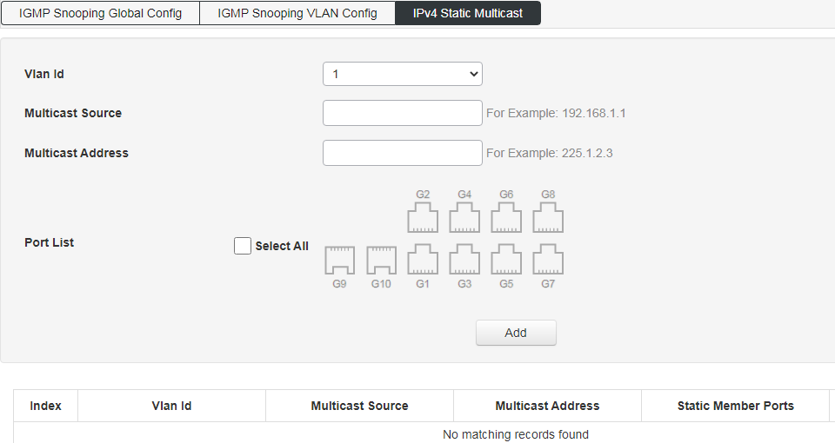

802.1x authentication
Global configuration: enable 802.1x authentication function.
Radius client address: configure radius authentication client address.
Radius server shared secret key: a secret of up to 29 characters is shared between the server and the switch.
Radius server timeout: (can be set to a number between 3 and 3600 seconds) It is the maximum time to wait for a response from the server. If the server does not respond within this time frame, we will consider it dead and continue to use the next enabled server (if any); the RADIUS server uses the UDP protocol, which is not reliable by design. In order to deal with the lost frames, the super interval is divided into three sub intervals, each of which has the same length. If no response is received within the subinterval, the request is transmitted again. This algorithm will cause radius server to be queried up to three times before it is considered as dead server.
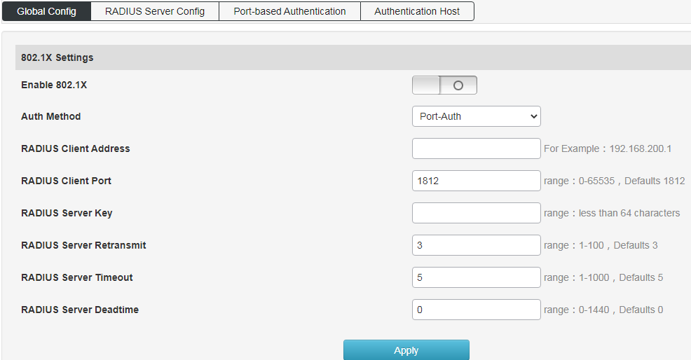
Radius server settings: set radius server attributes.
Radius server address: configure the radius server address.
Radius server port number: configure the radius server port number.
Radius server shared password: a secret of up to 29 characters is shared between the server and the switch.
Radius server retransmission times: configure the radius service death retransmission times.
Radius server timeout: (can be set to a number between 3 and 3600 seconds) is the maximum time to wait for a response from the server. If the server does not respond within this time frame, we will consider it dead and continue to use the next enabled server (if any). The RADIUS server uses the UDP protocol, which is not reliable by design. In order to deal with the lost frames, the super interval is divided into three sub intervals, each of which has the same length. If no response is received within the subinterval, the request is transmitted again. The server will be considered dead before the server is killed at most 3 times.
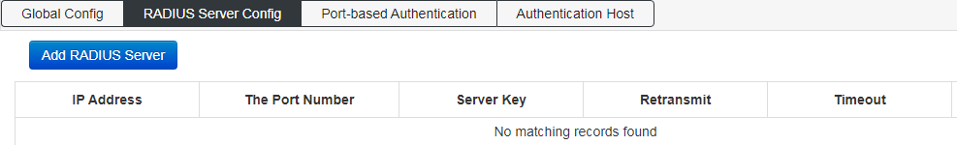
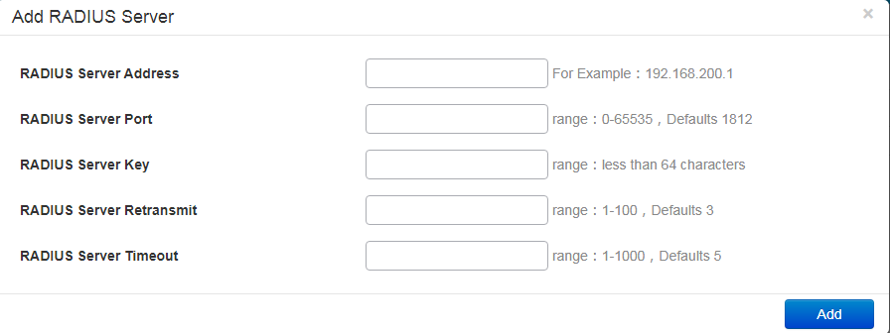
Port-based Authentication: Configure 802.1x authentication port.
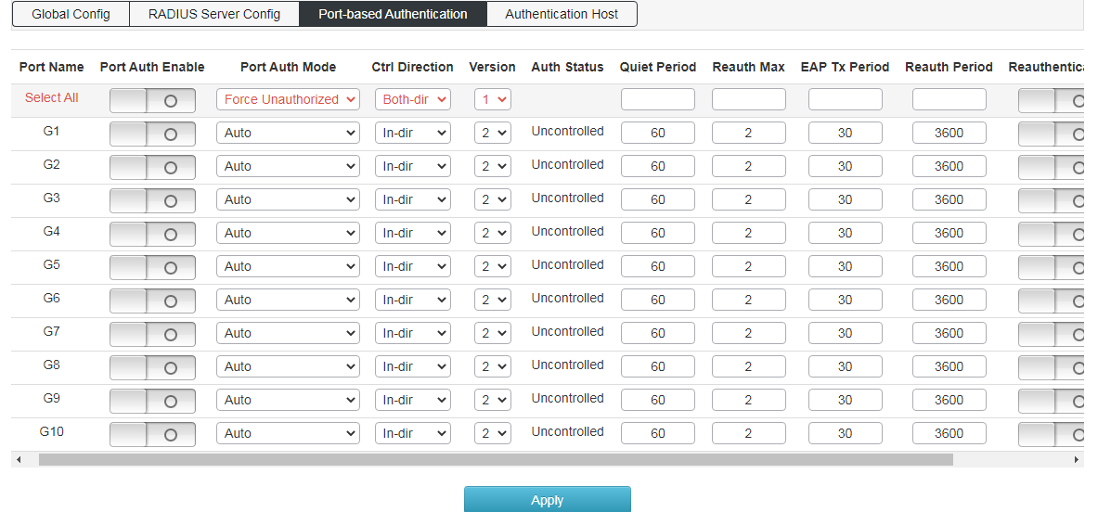
Authentication Host: View 802.1x authentication host properties.
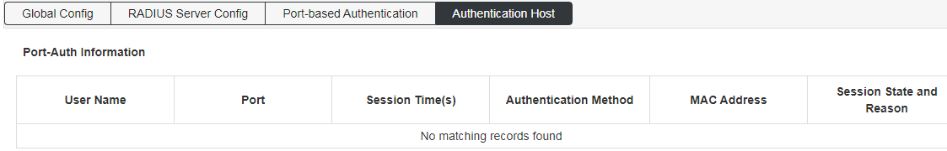

Senior Management

QOS Configuration
Global Configuration: Enable QoS function and configure QoS function properties.
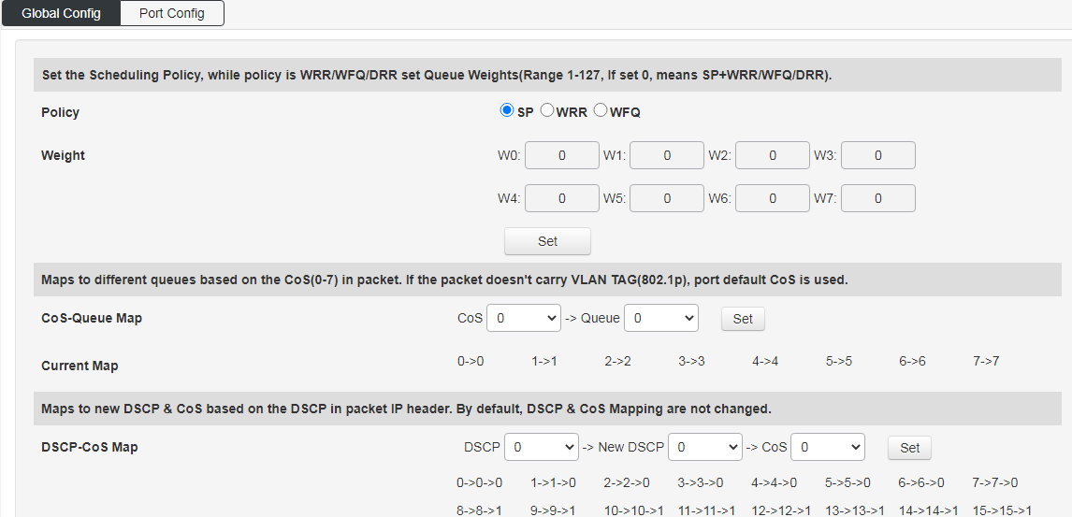
Port Configuration: Configure the QoS function properties on the port.
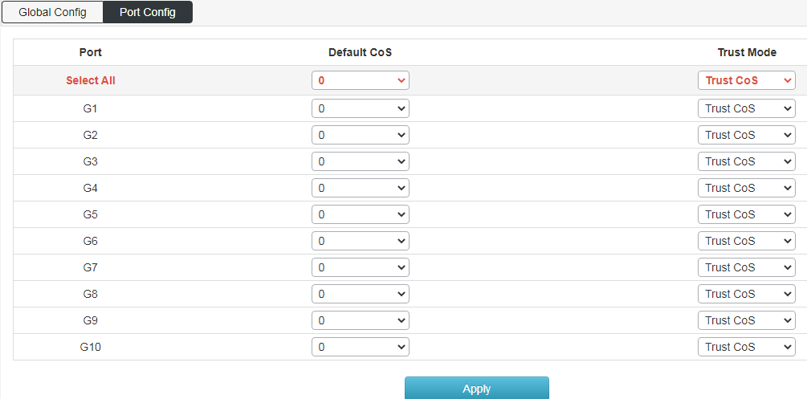

ACL Configuration
MAC ACL configuration：Configure MAC based ACL access list.
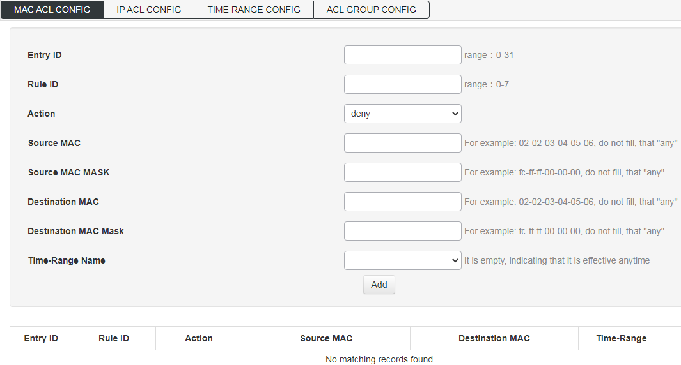
IP ACL Configuration：Configure IP based ACL access control list.
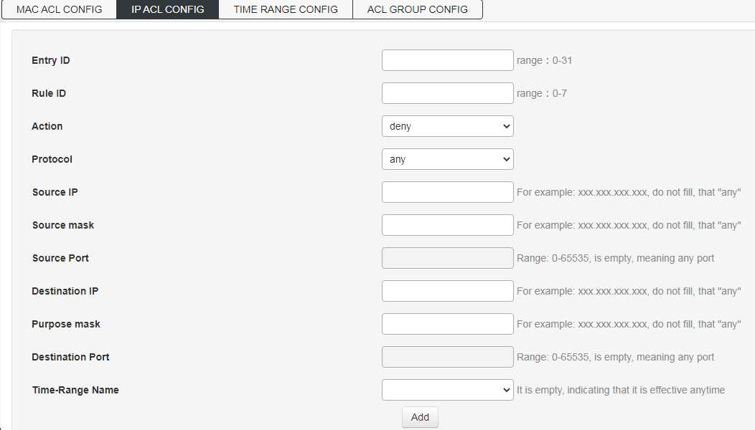
TIME RANGE Configuration：ACL time range setting.
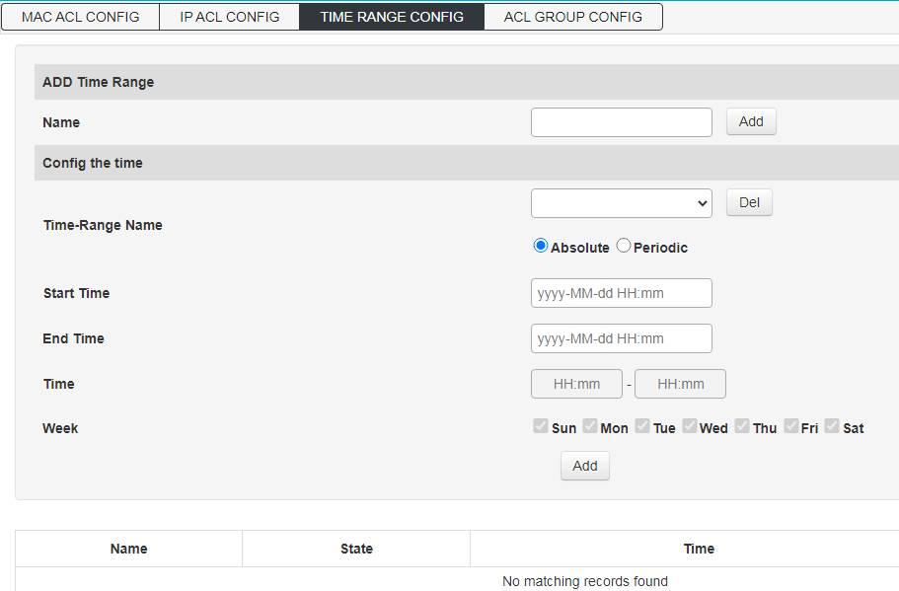
ACL GROUP Configuration：Configure ACL access control list port group.
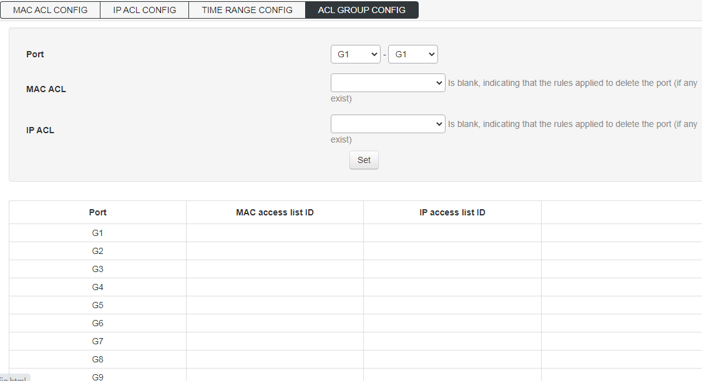

SNMP Configuration
System Information：Enable all SNMP protocol versions, configure SNMP protocol system properties and enable trap function.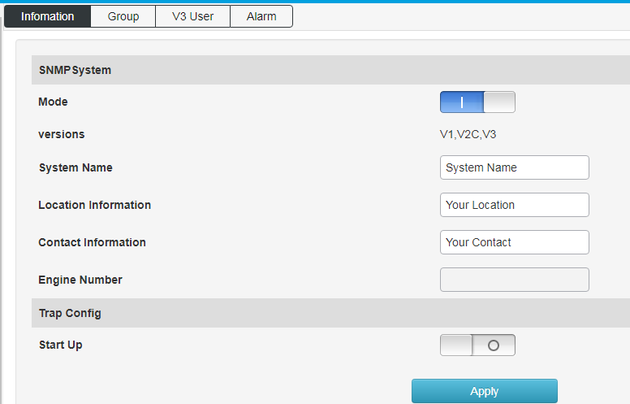
Group: Configure SNMP community properties.
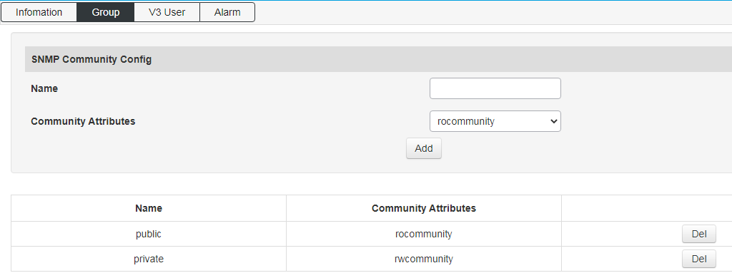
V3: configure the member attribute of SNMP V3 protocol version.
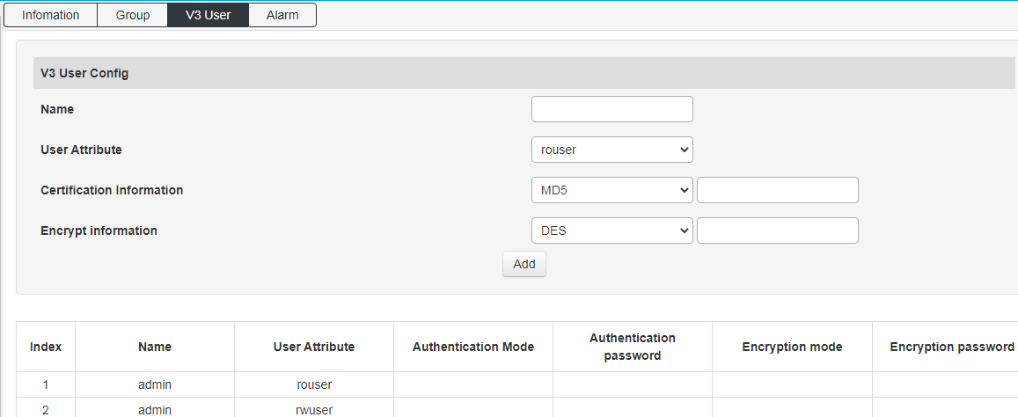
Trap: configure trap receiving address and corresponding SNMP protocol version.
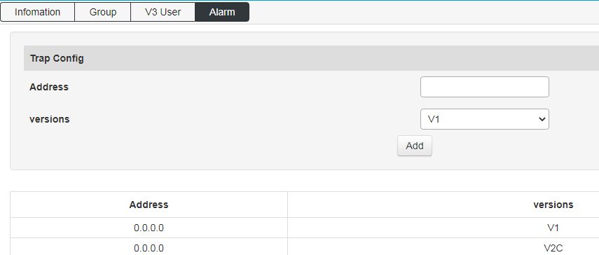

RMON
Event group: query and add event groups monitored remotely.
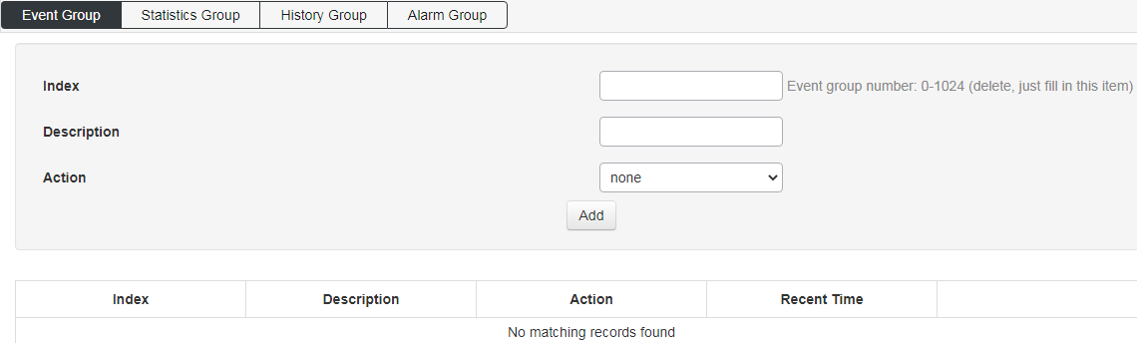
Statistics group: query the statistical information of specific events after the event is broken.
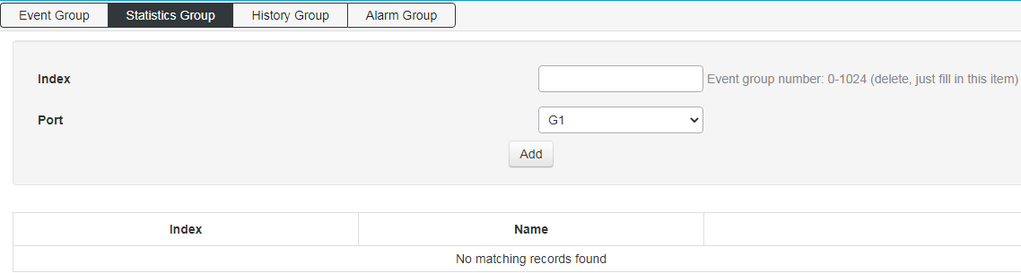
History group: add and query the history of a specific event at the port.
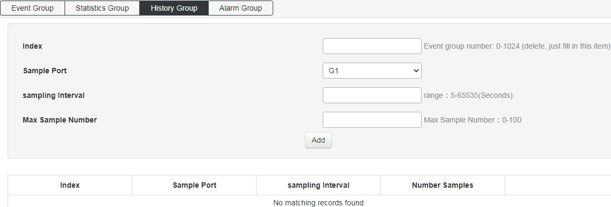
Alarm group: add the attribute of alarm event query on the port.
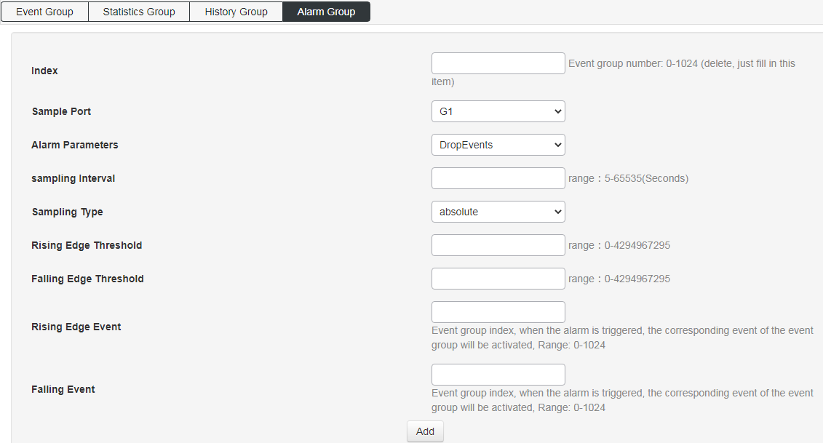

LLDP Configuration
Global configuration: turn on and configure LLDP function attributes.
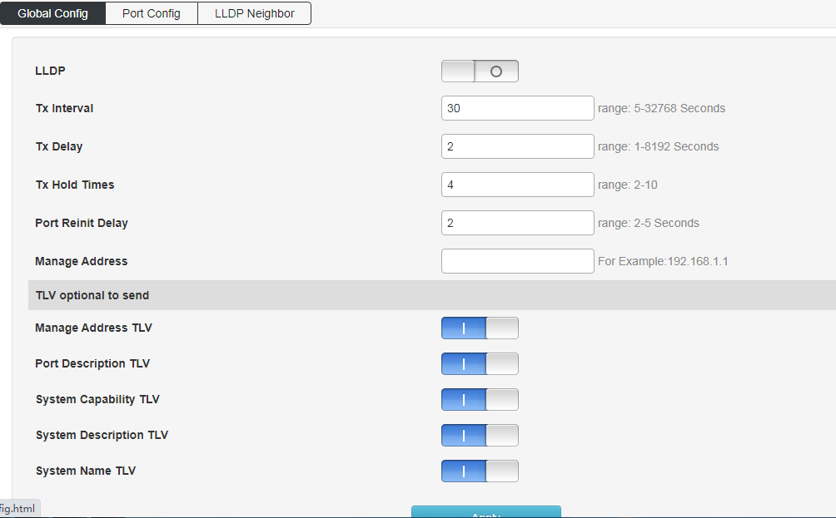
Port configuration: configure port LLDP function attributes.
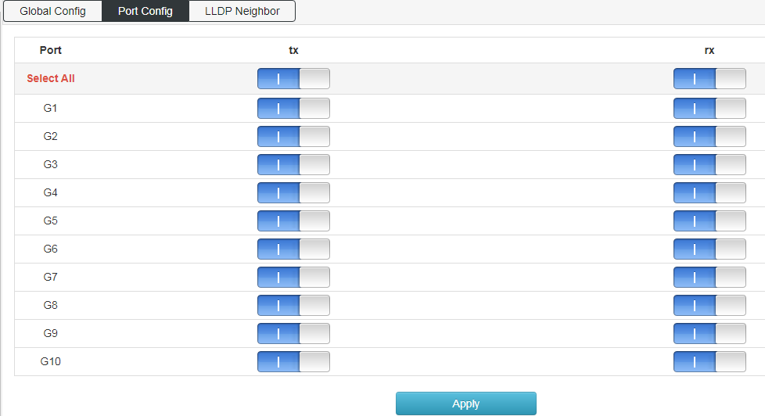
LLDP邻居：查询LLDP邻居信息；

NTP Configuration
Global configuration: configure NTP function enable, time zone selection and check the modification of time interval.
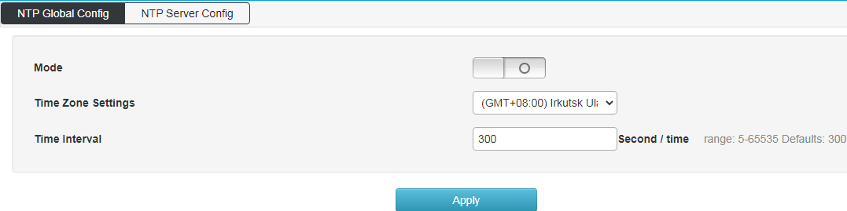
NTP server configuration: configure the NTP server address and view the NTP server status.
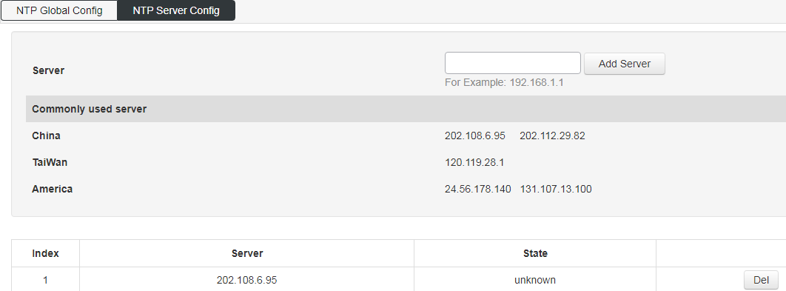

Anti Attack
It can open DDoS and ICMP echo;
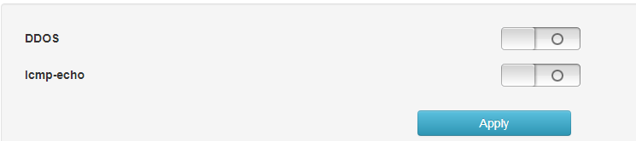

System Management

User Settings
Modify the user login password, the account name can not be changed or added users.
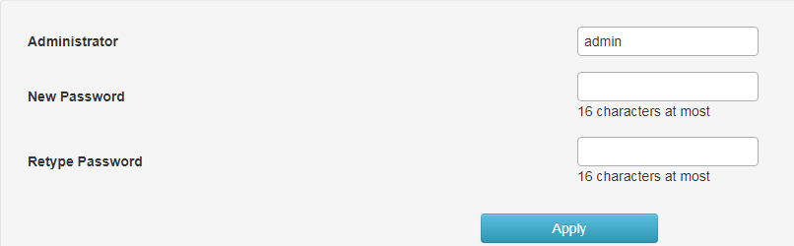

Network Settings
IPv4 configuration: modify the IPv4 address of the switch, cannot add IP address.
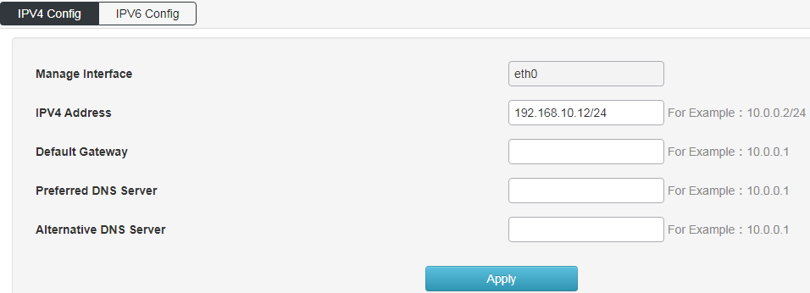
IPv6 configuration: modify the IPv6 address of the switch, cannot add IP address.
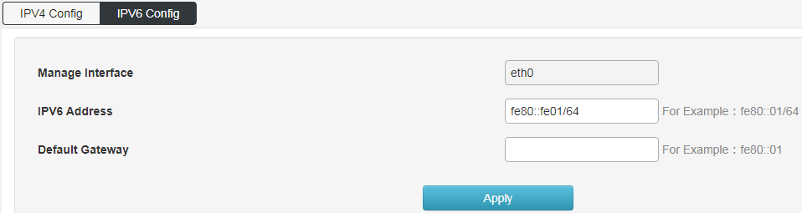

Alarm Configuration
Configure switch alarm function to enable.
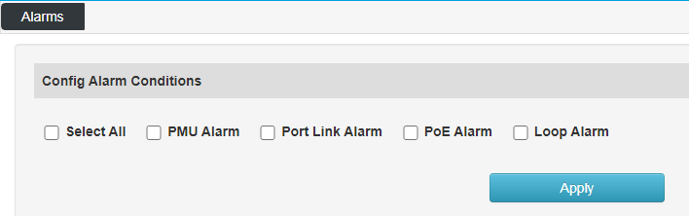

Service Configuration
Configure switch Telnet, SSH, HTTP version protocol and service port.
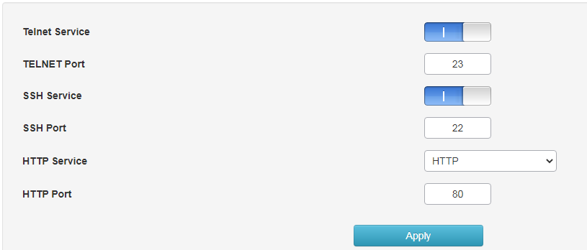

Configuration Management
For reset, upload and download switch configuration.
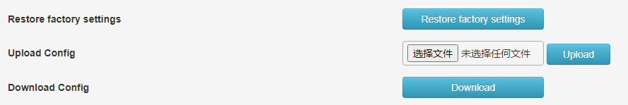

Firmware Update
It is used to upgrade the software version of the switch.
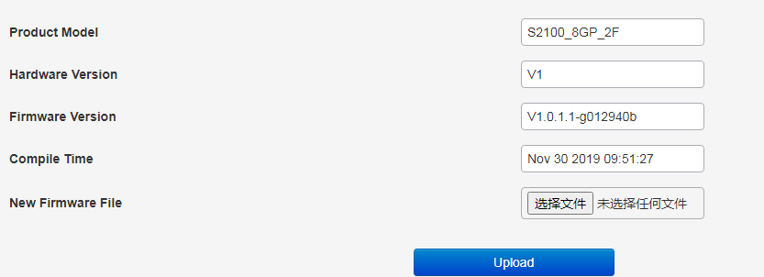

Diagnostic Testing
Ping detection: use the ping function of the switch to detect whether the link between the switch itself and other IP devices is smooth.
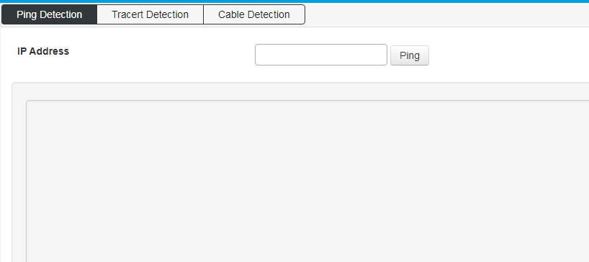
Tracert detection: Traceroute.
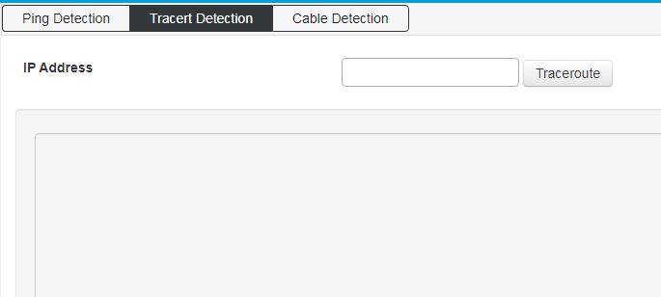
Network line detection: detect the network line attribute of all network ports of the switch.
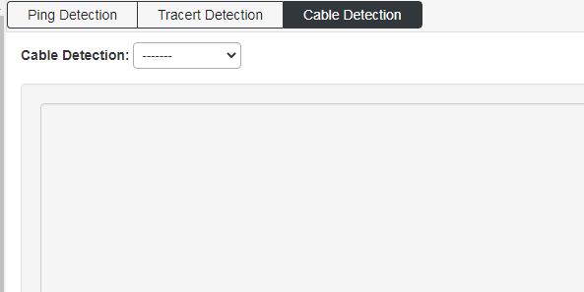

Reboot Device
Restart the switch.
